Extending and Predicting Elements in Patterns Behaviours/Strategies
- Student looks at the letter core, but has  difficulty choosing beads to represent the core. | - Student represents the core with beads, but  struggles to use copies of the core to extend the pattern.  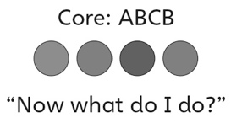 | - Student represents the core with beads, but  struggles to predict an element in the pattern.  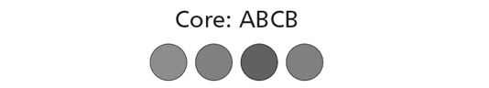  “I am not sure what bead 15 will be.”
Observations/Documentation
- Student correctly predicts an element in the core, but struggles to justify prediction.  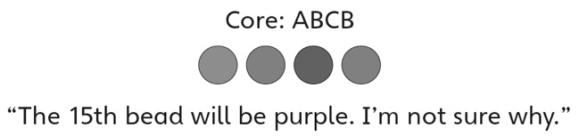 | - Student predicts an element in the core and  justifies prediction, but does not realize that,  because the pattern is circular, the pattern core can be viewed differently, depending on the starting point. | - Student successfully represents the core with  beads, predicts element, justifies thinking, and is comfortable with circular patterns.
Observations/Documentation

