Predicting Missing Elements and Correcting Errors Behaviours/Strategies
- Student chooses a pattern, but struggles to  identify the repeating unit (core) of the pattern.  “I don’t know what the core is.” | - Student identifies the repeating unit (core) of  some patterns, but struggles when there is a  missing element or error near the beginning of  the pattern.  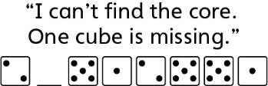 | - Student identifies the repeating unit (core) of  a pattern, but struggles to find and correct the  error.  “I know the core, but I can’t find the error.”
Observations/Documentation
- Student identifies the repeating unit (core) of  a pattern, but struggles to predict the missing  element.  “I know the core, but I don’t know  what’s missing.” | - Student successfully identifies missing  element(s) and corrects errors in repeating  patterns, but struggles to explain how an error  or missing element was found. | - Student successfully identifies the repeating unit (core) of a pattern, predicts missing element(s),and corrects errors in repeating patterns.
Observations/Documentation

