Increasing Patterns Behaviours/Strategies
- Student chooses materials, but struggles to  create an increasing pattern and randomly  groups items together.  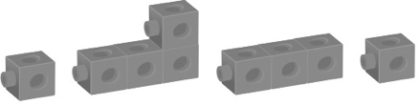 | - Student creates an increasing pattern, but  struggles to explain rule for partner’s pattern. | - Student creates an increasing pattern, but  struggles to examine partner’s pattern for  errors or missing terms.
Observations/Documentation
- Student identifies and creates an increasing  pattern, but struggles to extend the pattern by  two terms. | - Student identifies, creates, and extends an  increasing pattern, but struggles to reproduce  the pattern another way. | - Student successfully identifies, creates,  reproduces, and extends an increasing pattern  and explains the pattern rule.
Observations/Documentation

