Equal or Not Equal? Number Sentences
Master 35a

Write = or < or > in each box.
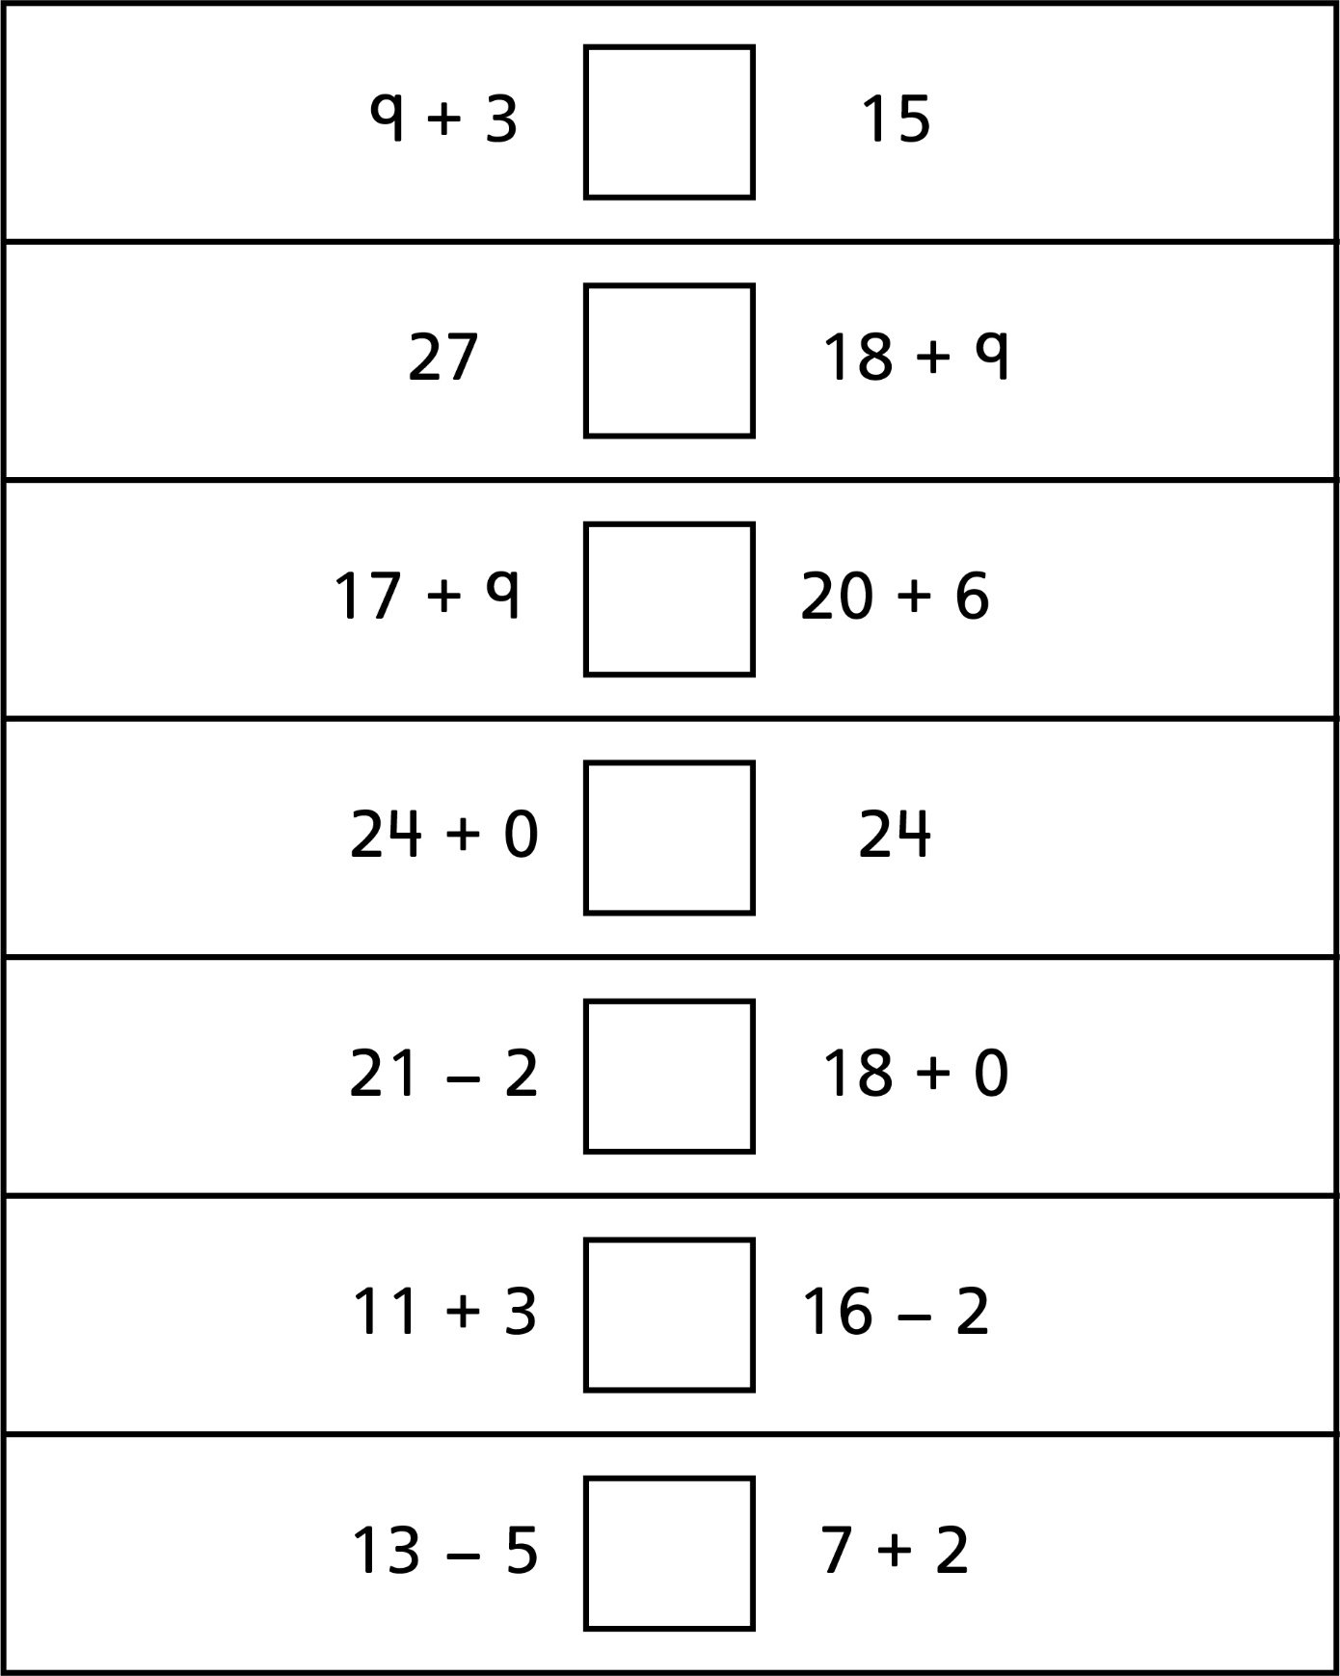
Equal or Not Equal? Number Sentences
Master 35b

(for Accommodations)
Write = or < or > in each box.
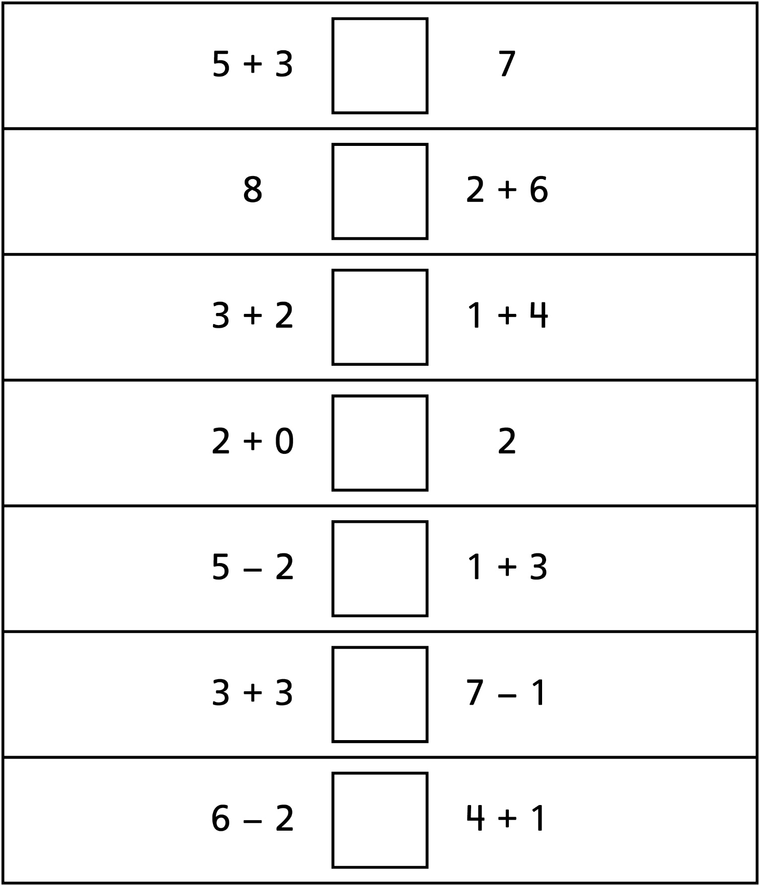
Equal or Not Equal? Number Sentences
Master 35c

(for Combined Grades Extension)
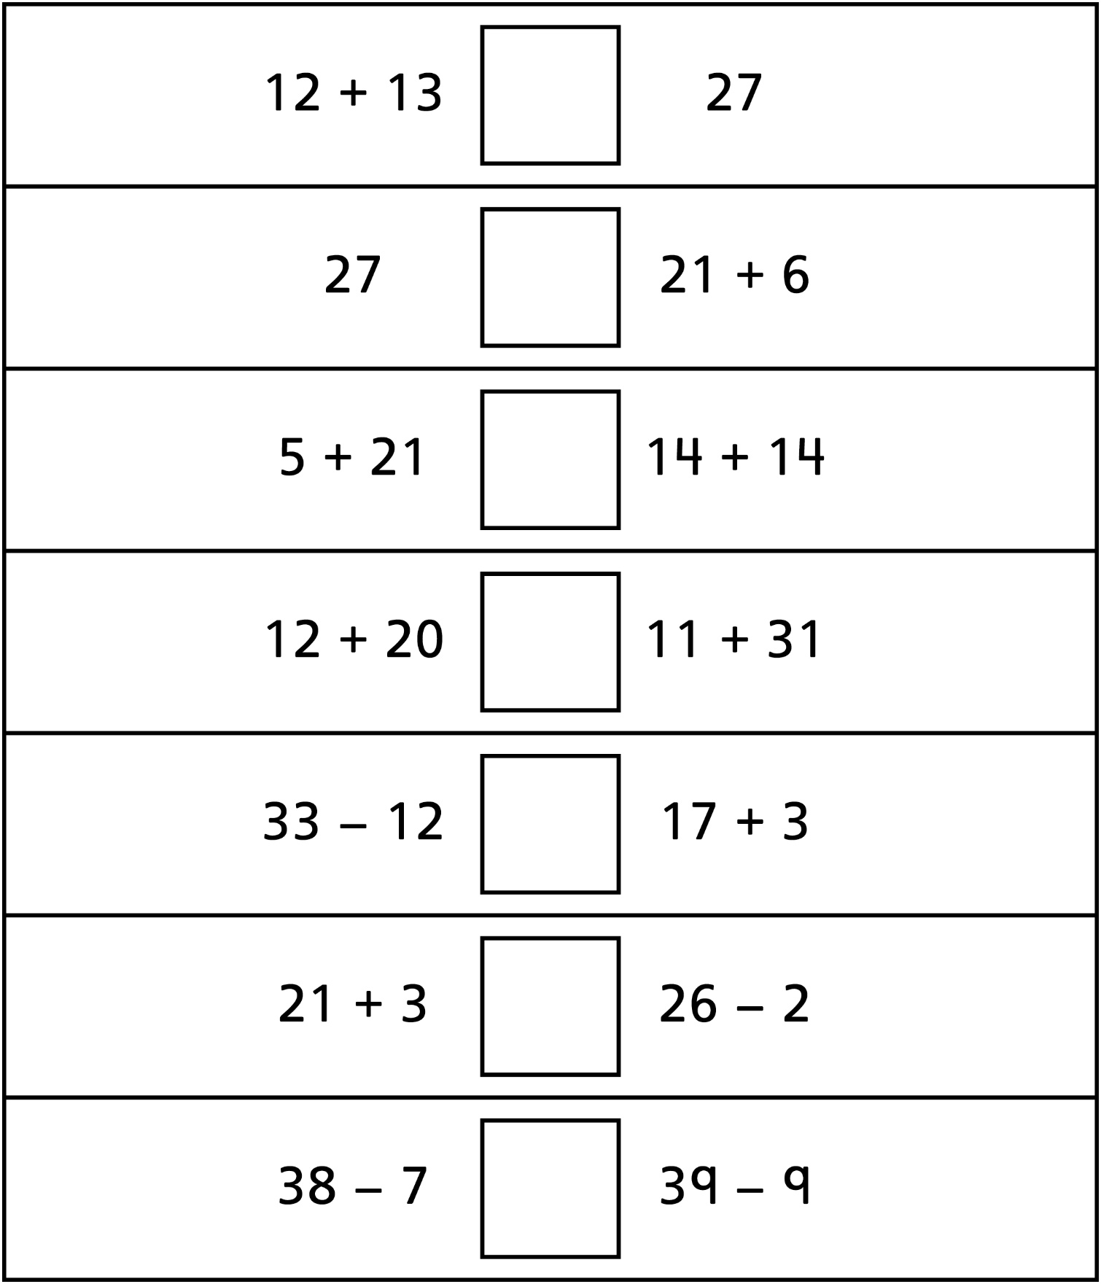
Write = or < or > in each box.

