**Find the Missing Number Cards**

**Master 37a**

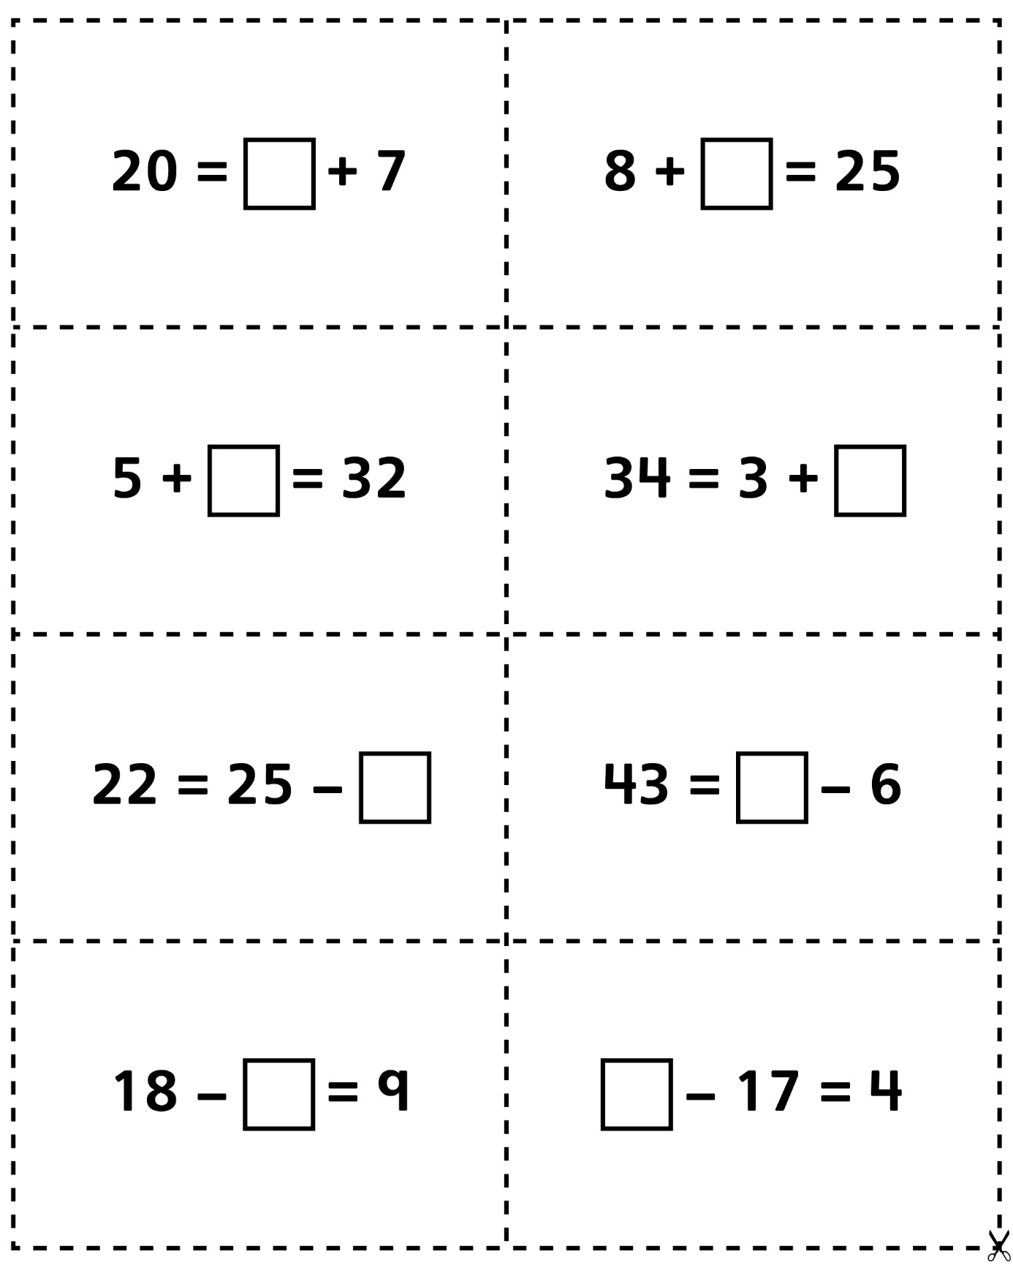

**Find the Missing Number Cards**

**Master 37b**

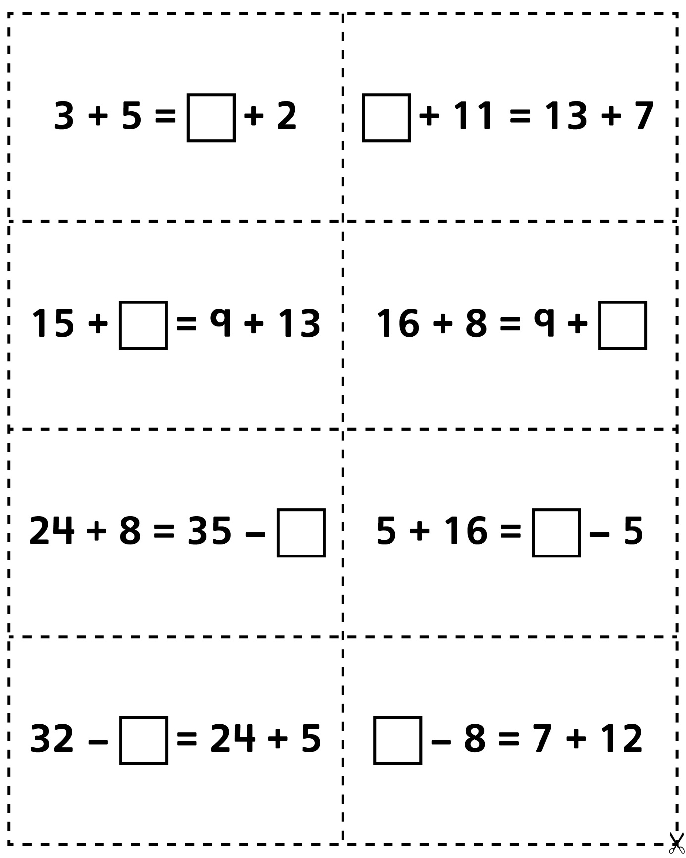



**Find the Missing Number Cards**

**Master 37c**

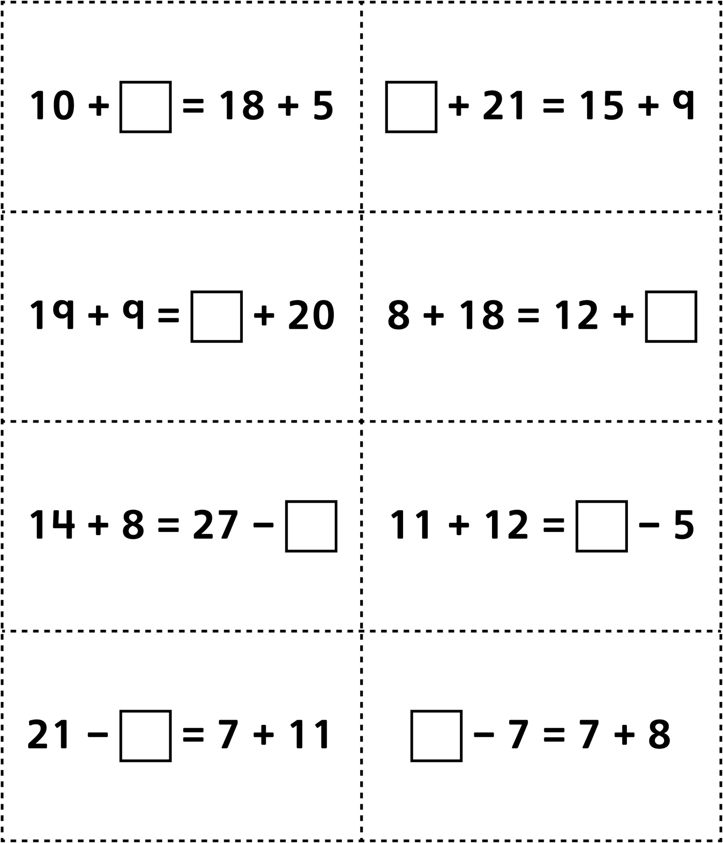

**Find the Missing Number Cards**

**Master 37d**

**(for Accommodations)**

