Making Concrete Graphs and Pictographs Behaviours/Strategies
- Student labels columns, but is  unable to sort objects to create  display. | - Student creates display, but sorts  objects into piles or bunches  pictures together on graph.  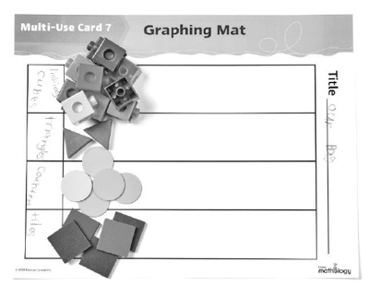 | - Student creates display, but objects/pictures are not equally spaced and aligned or pictures have different sizes.  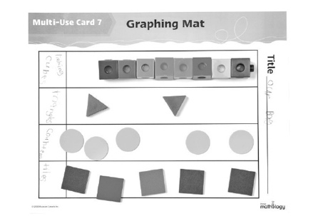 | - Student successfully creates  displays using objects or simple  pictographs.  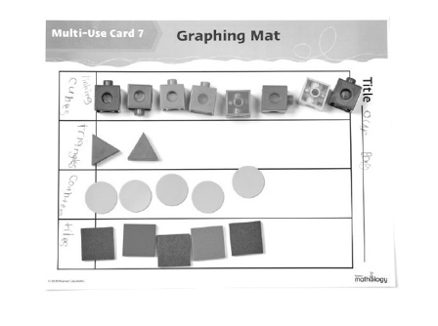
Observations/Documentation
Reading and Interpreting Graphs Behaviours/Strategies
- Student reads displays, but counts objects/pictures twice or mixes up the number word sequence. | - Student reads displays, but  struggles to interpret data to  answer “how many” questions. | - Student reads displays, but  struggles to interpret data to  answer comparison questions  (e.g., how many more/less). | - Student successfully interprets  displays by noting how many  more/less than other categories.
Observations/Documentation

