Graphs and Tables
Master 21a

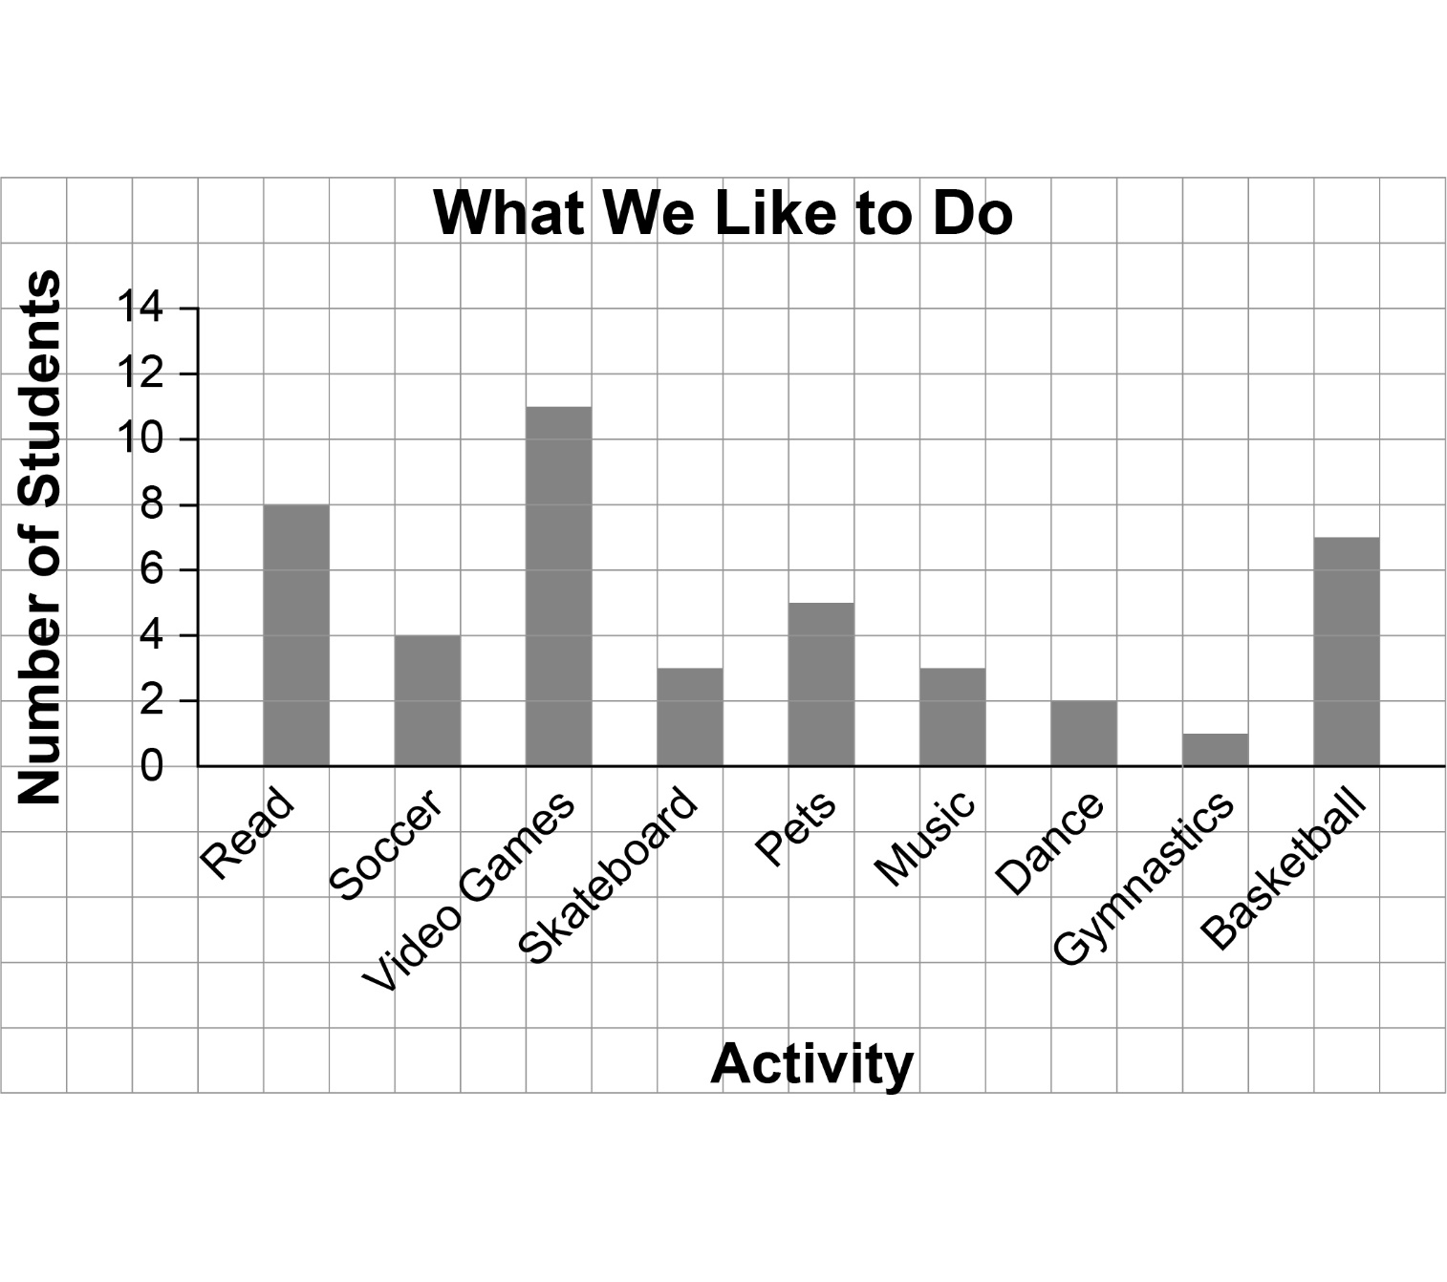
Source: Gr. 2 Class at Hillsdale Elementary School
Graphs and Tables (con’t)
Master 21b

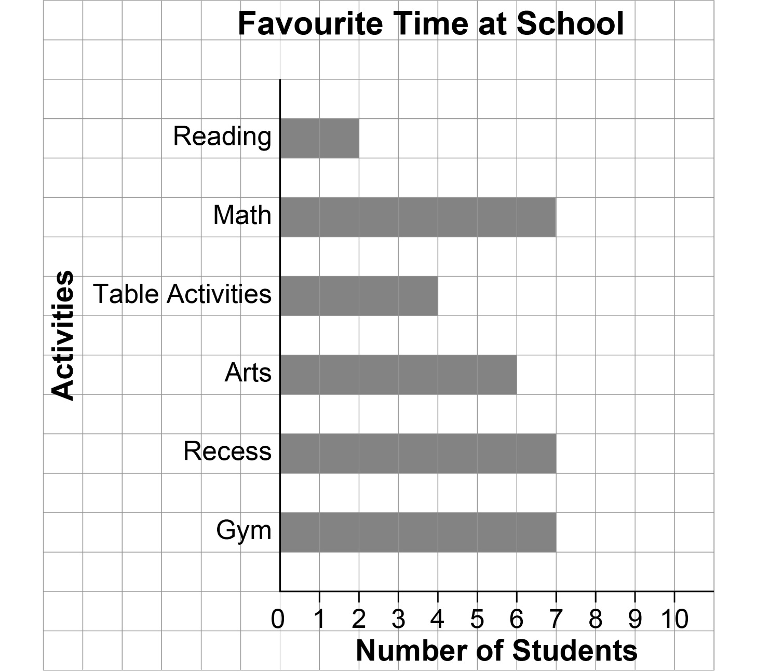

Source: Gr. 2 Class at Hillsdale Elementary School

Graphs and Tables (con’t)
Master 21c

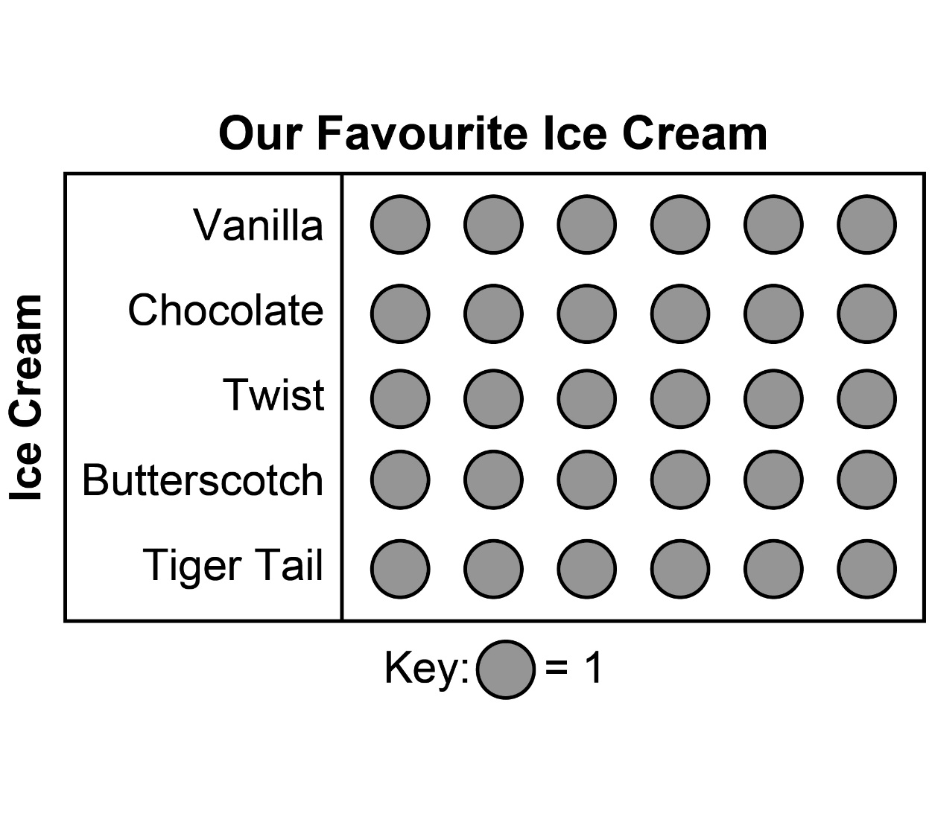
Source: Gr. 2 Class at Hillsdale Elementary School

Graphs and Tables (con’t)
Master 21d

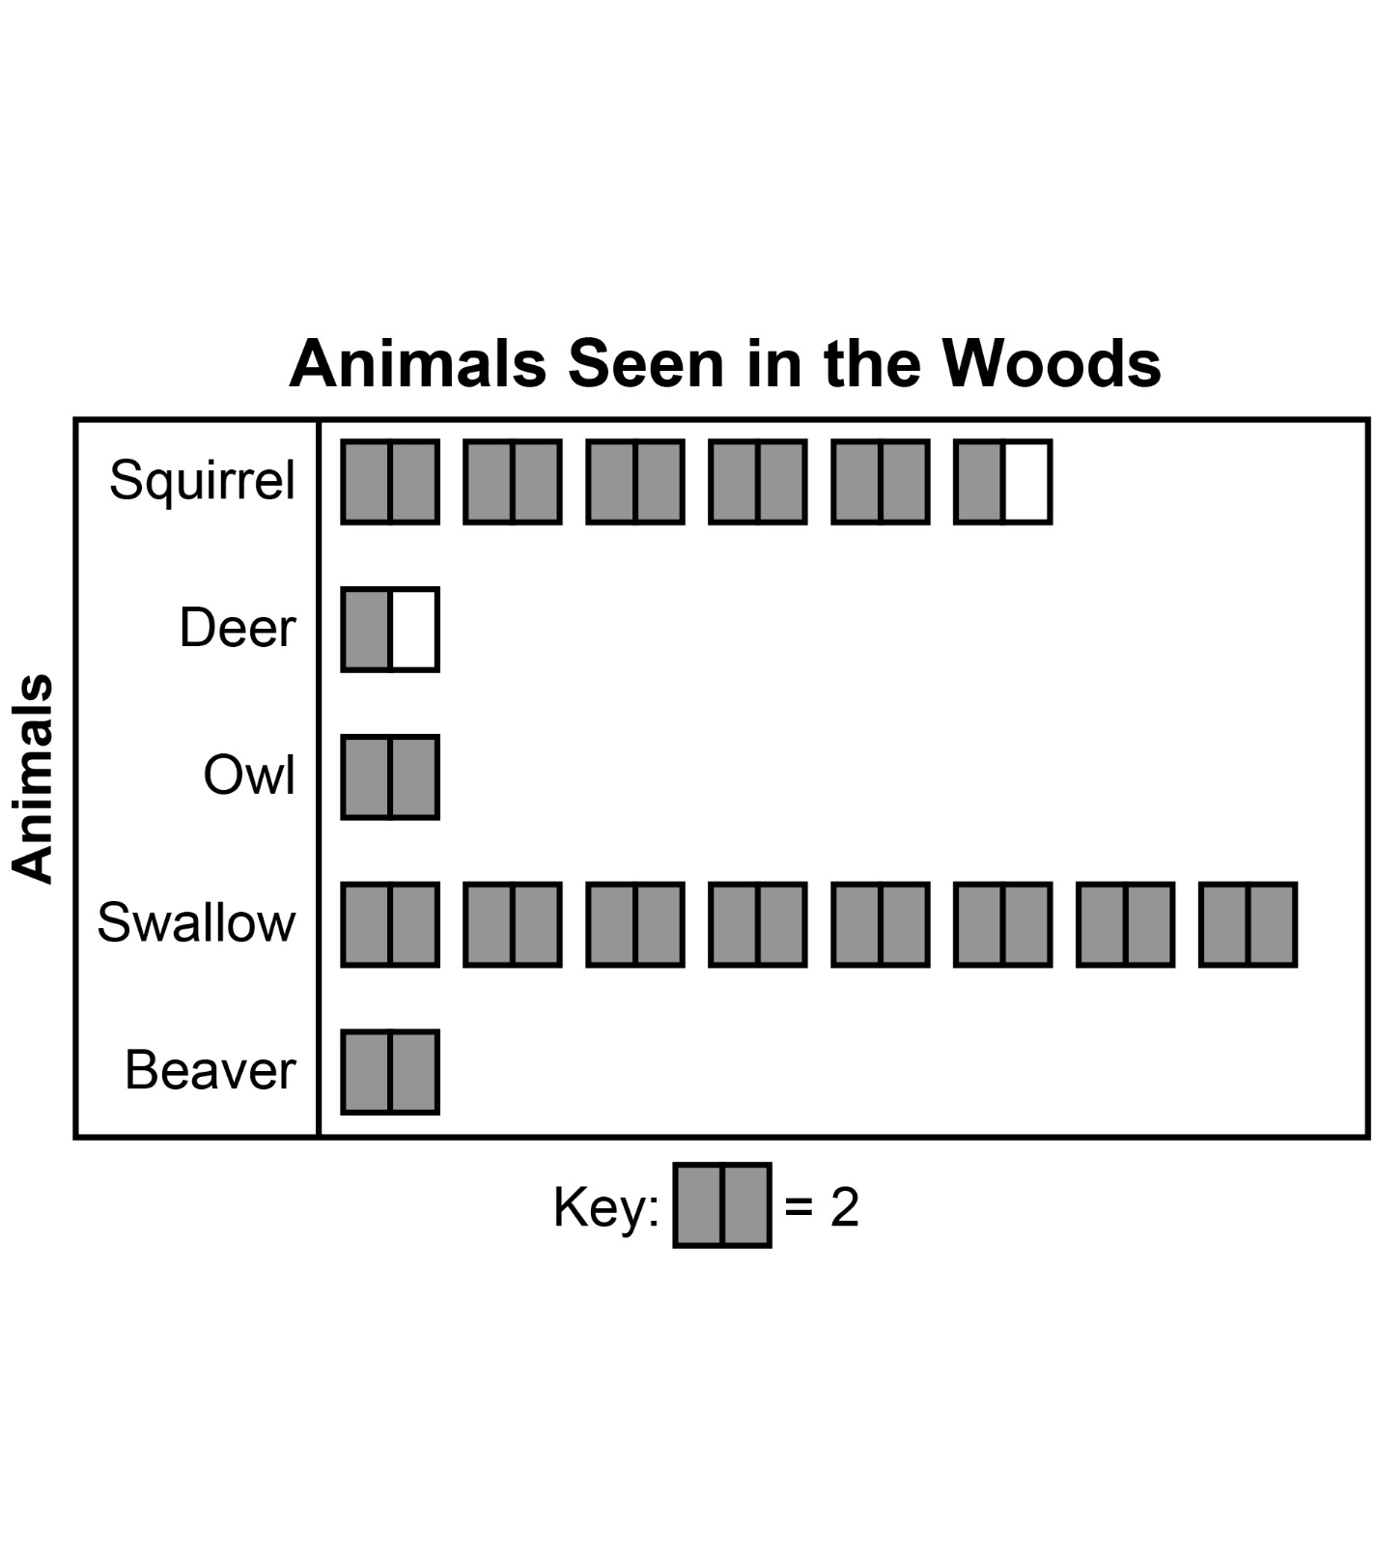
Source: Gr. 2 Class at Hillsdale Elementary School

Graphs and Tables
Master 21e

Jason’s  Trading Cards |  | Type of Card
 |  | Game Cards | Sports Cards
Conditions | Good | |||| ||||  |||| ||||  |||| ||| | |||| ||||  |||| ||||
 | Fair | |||| | | |||| ||||
 | Poor | |||| ||| | |||| ||||  ||

