Identifying the Mode of a set of Data Behaviours/Strategies
- Student identifies which categories have the most and the least, but has difficulty identifying the mode.  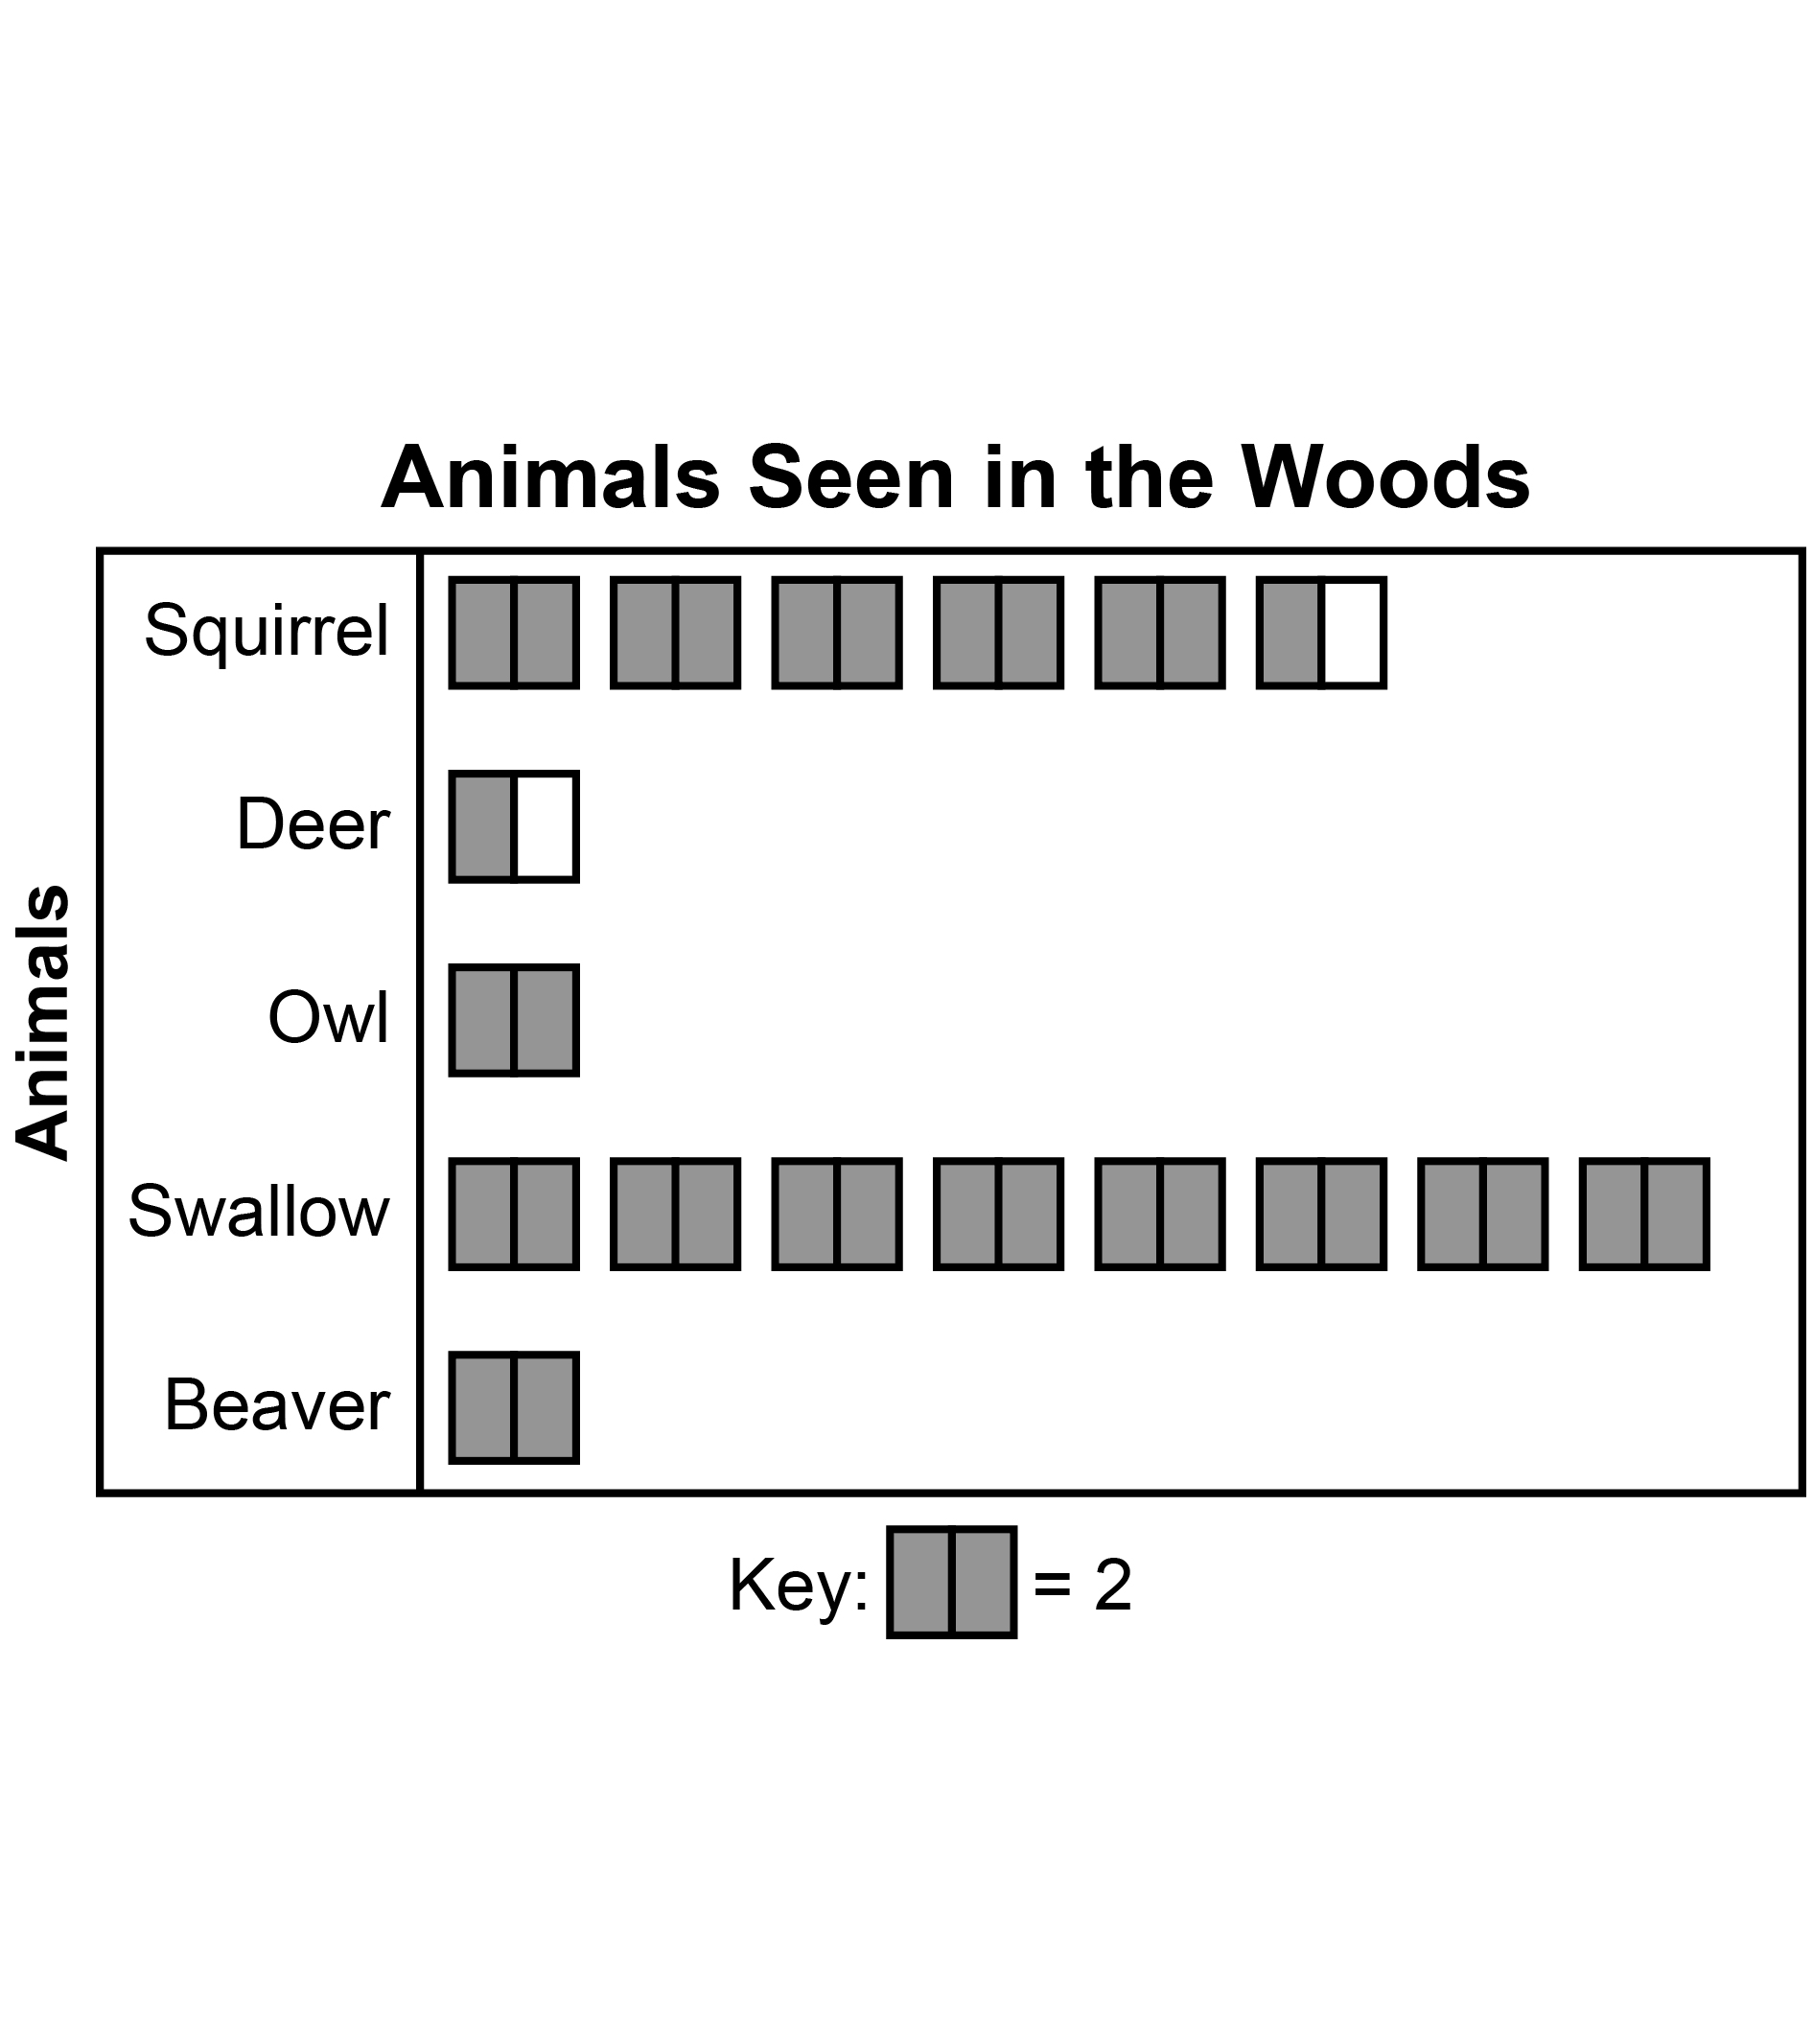  “Swallows were seen the most, deer were seen the least.” | - Student identifies the mode on graphs or tables that have one mode, but has difficulty when graphs have multiple modes.  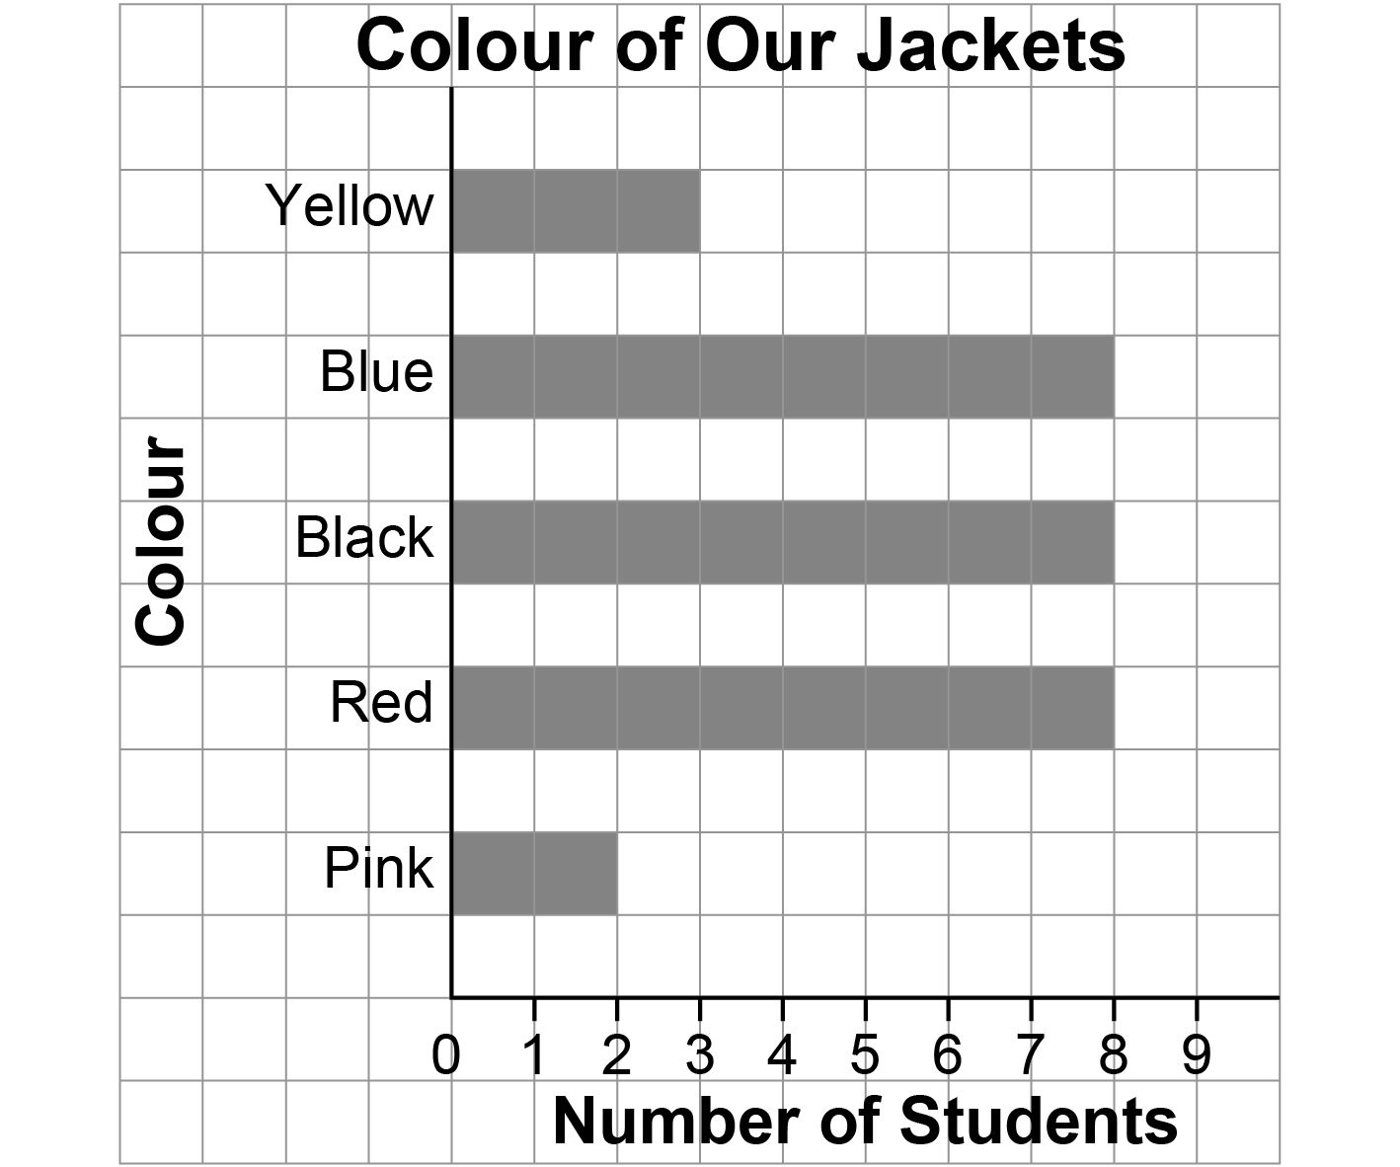  “On this graph, I can’t tell what the mode is.” | - Student identifies multiple modes, but has difficulty when graph has no mode.  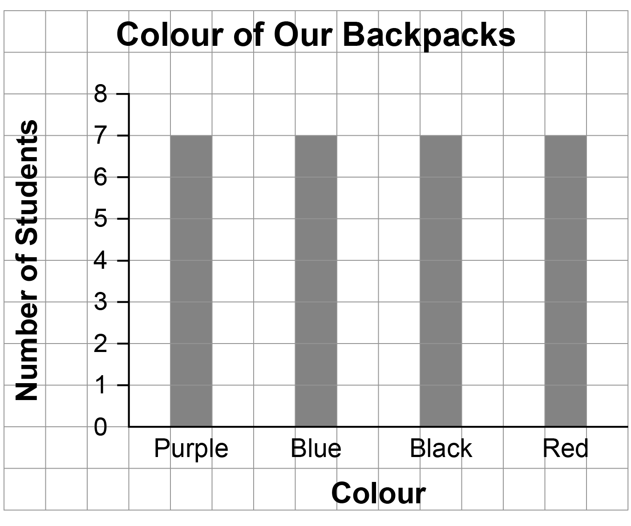  “There’s more than one mode.” | - Student flexibly identifies one mode, multiple modes, and no mode in data sets and explains what the mode(s) tells us about the data.  “The data has one mode, ‘Swallow.’ It’s the animal people saw the most.”
Observations/Documentation

