Exploring the Likelihood of Events Behaviours/Strategies
- Student creates a bag or spinner, but is unable to use a chance word to describe the likelihood of events and/or complementary events. | - Student uses a chance word to describe the  likelihood of events, but decision is based on beliefs or what he or she wants to happen.  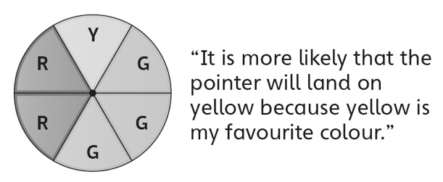 | - Student uses a chance word to describe the  likelihood of events, but always uses impossible  or misuses some chance words (e.g., mixes up  more likely and certain).  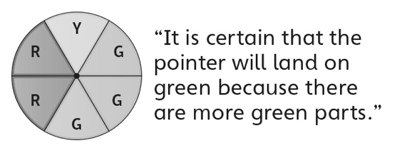
Observations/Documentation
- Student uses a chance word to describe the  likelihood of events, but struggles to justify  thinking.  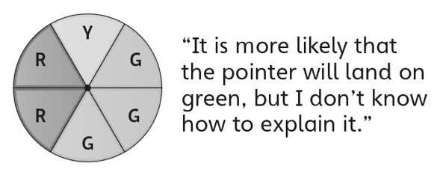 | - Student describes the likelihood of events, but  does not understand why results of experiment do not match prediction.  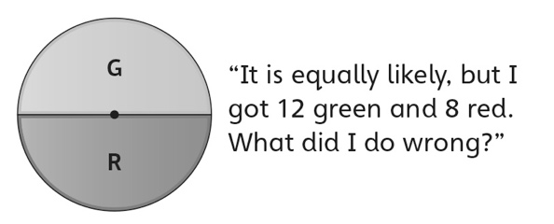 | - Student successfully describes the likelihood  of events and performs simple experiments to  verify predictions.
Observations/Documentation

