Describing the Likelihood of Events Behaviours/Strategies
- Student draws pictures randomly along the line and is unable to describe the likelihood of events. | - Student attempts to describe the likelihood of  events, but decision is based on beliefs or what he or she wants to happen.  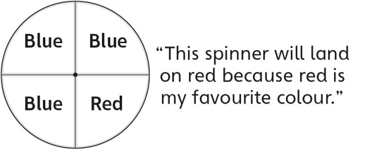 | - Student describes the likelihood of some events, but mixes up or misuses some chance words (e.g., mixes up less likely and impossible).  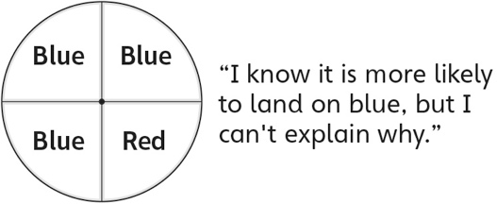
Observations/Documentation
- Student describes the likelihood of impossible  and certain events, but struggles to describe the likelihood of complementary events happening.  “I’m not sure if it’s more or less likely.” | - Student describes the likelihood of events and  compares the likelihood of two events, but  struggles to justify thinking.  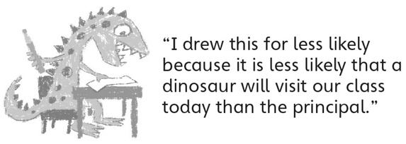 | - Student describes the likelihood of events,  compares the likelihood of two events, and  justifies thinking.
Observations/Documentation

