**Attribute Cards for Activity 2**

**Master 2a**

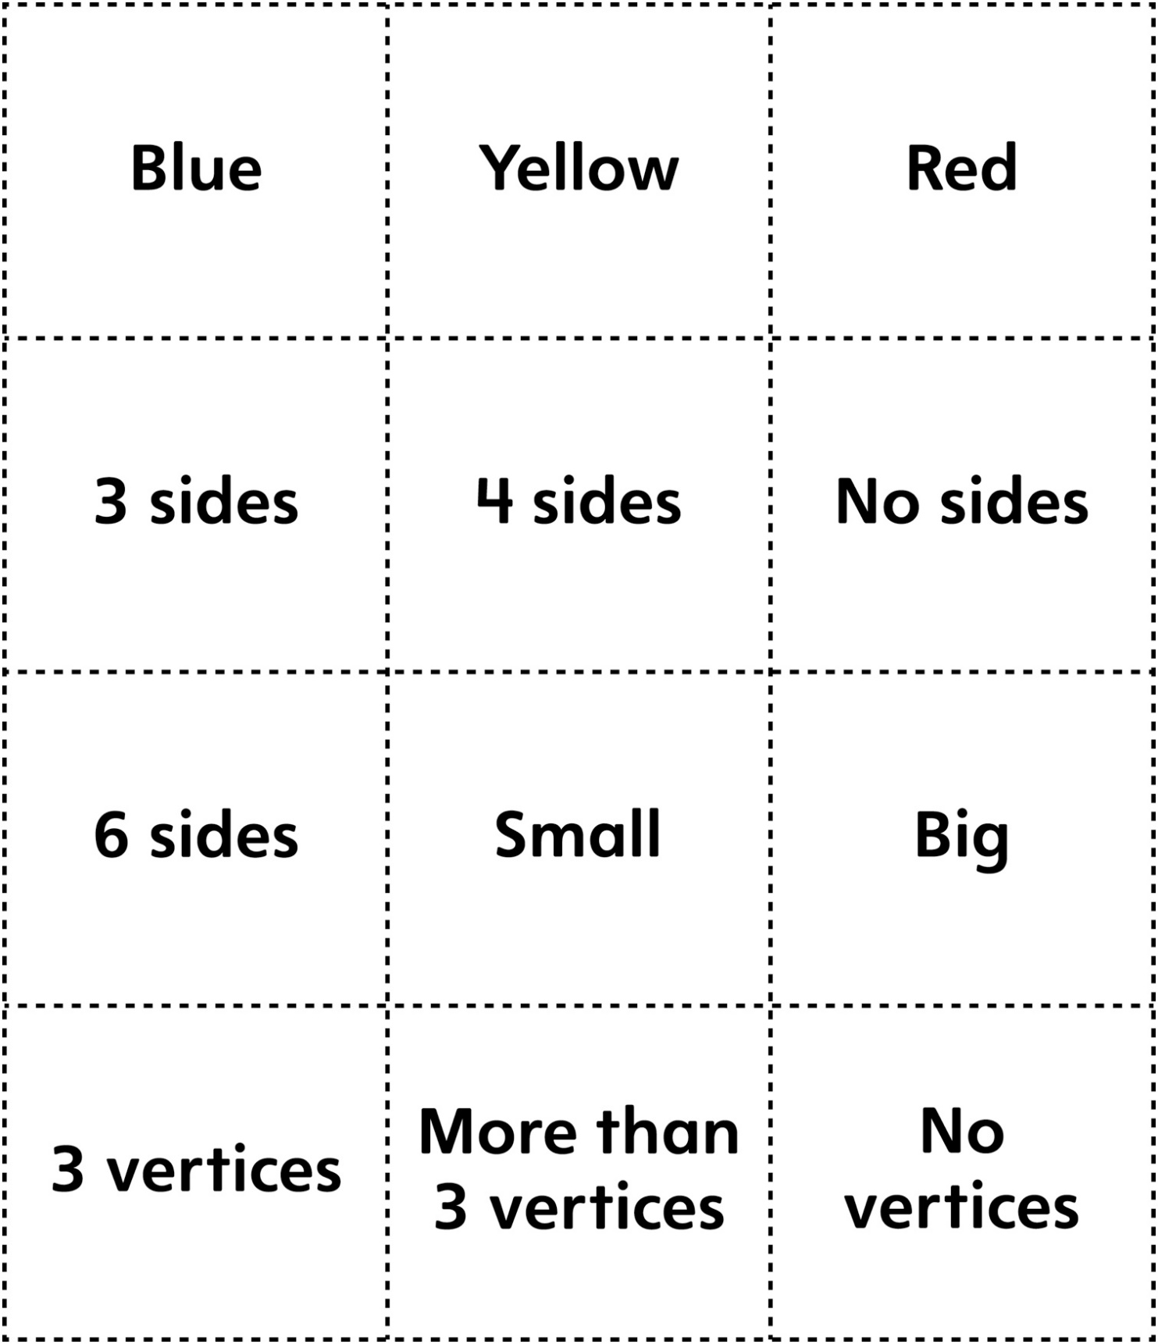

**Attribute Cards for Activity 2**

**Master 2b**

