**Symmetry Cards**

**Master 9a**

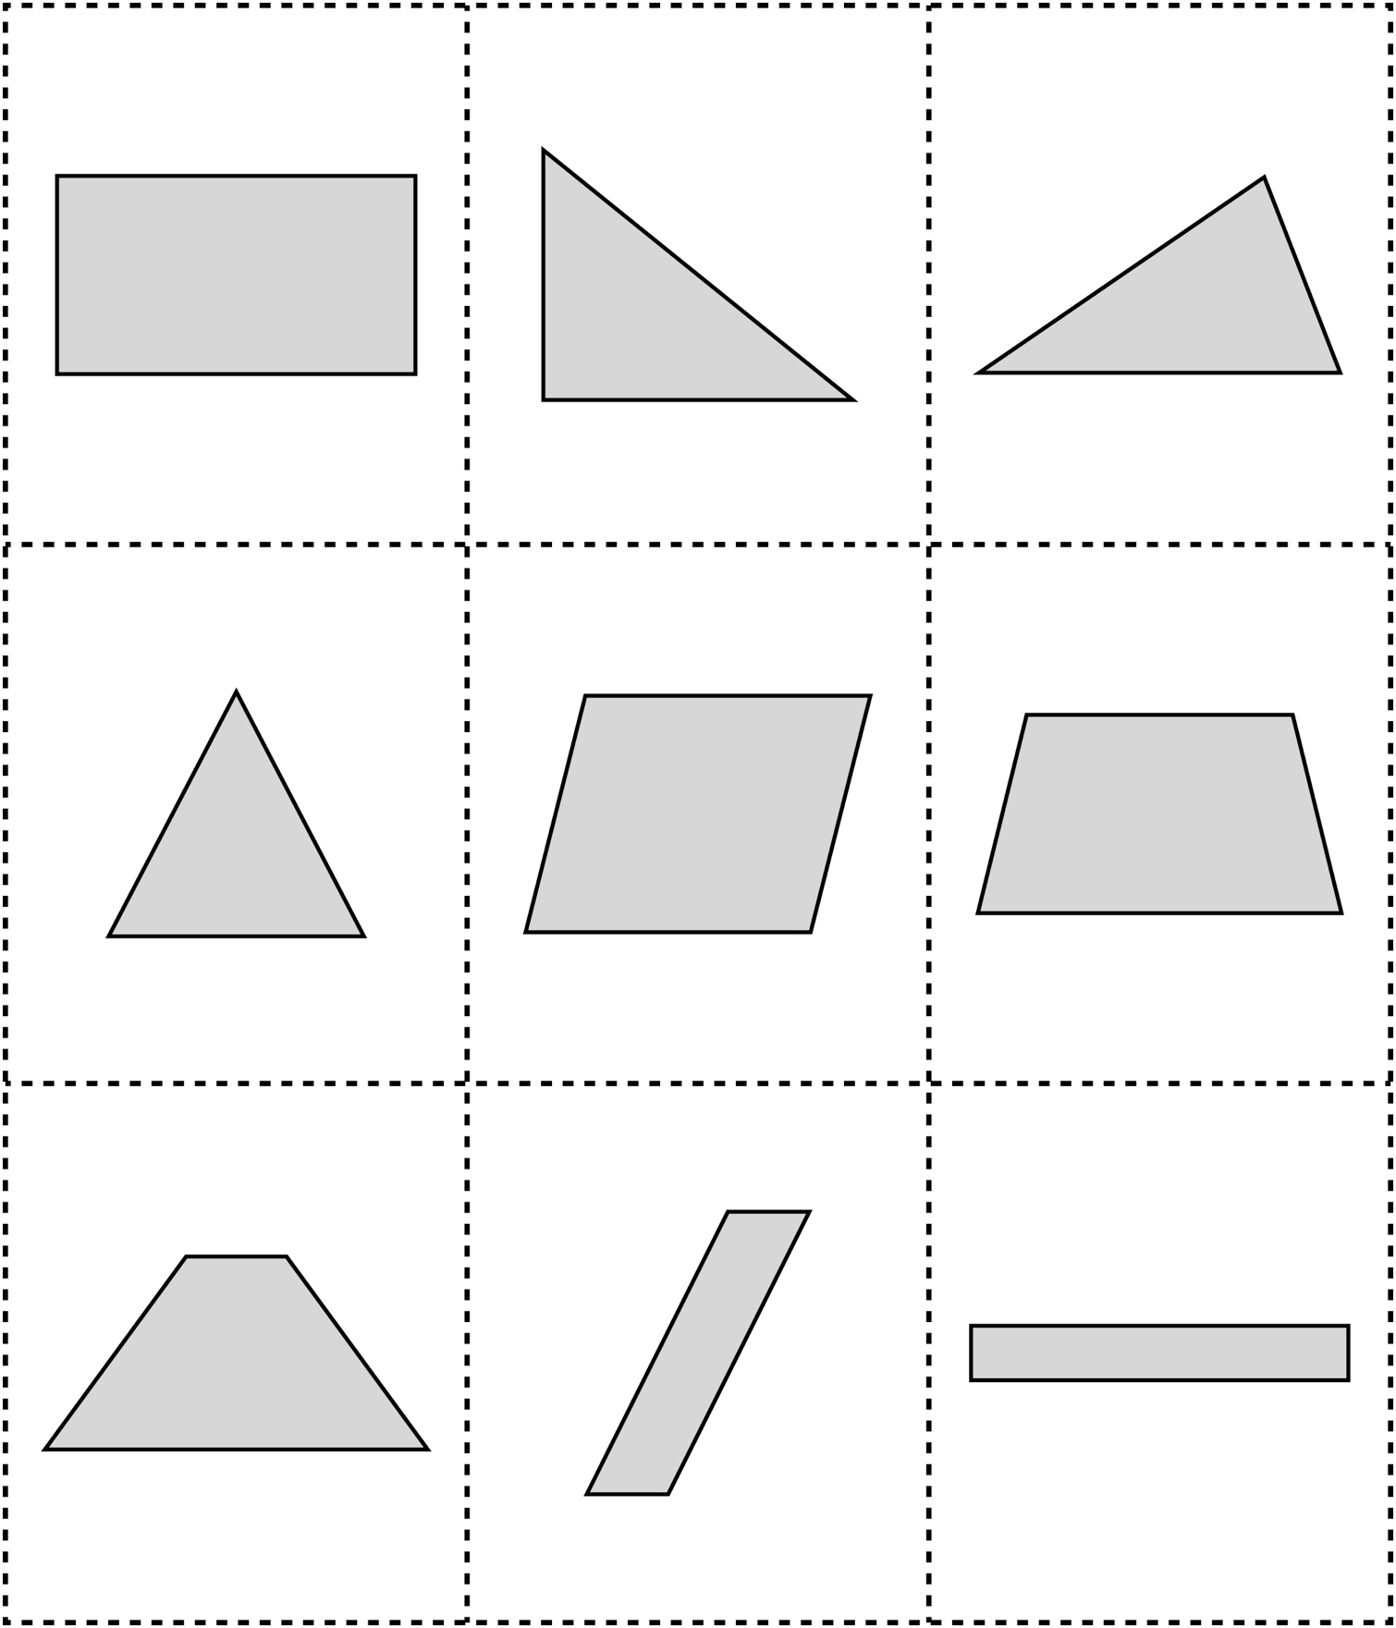

**Symmetry Cards (for Extension)**

**Master 9b**

