Identifying Lines of Symmetry Behaviours/Strategies
- Student turns over a card, but is unable to  identify a line of symmetry on the 2-D shape.  “I don’t know how to find it.” | - Student identifies and draws what he or she  thinks is a line of symmetry, but does not fold  the shape to check.  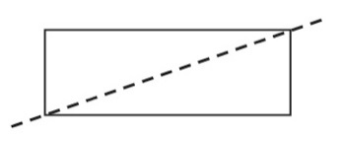 | - Student identifies a line of symmetry, but does  not realize that the shape has more than one  line of symmetry.  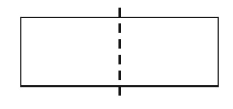
Observations/Documentation
- Student identifies lines of symmetry on most  2-D shapes, but does not realize that a shape  can have no lines of symmetry.  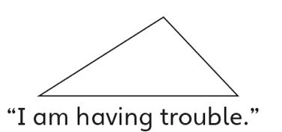 | - Student identifies all lines of symmetry on 2-D  shapes, but struggles to sort the shapes on the sorting mat.  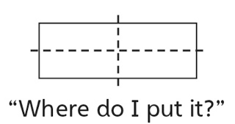 | - Student successfully identifies all lines of  symmetry on 2-D shapes and sorts them on the  sorting mat.  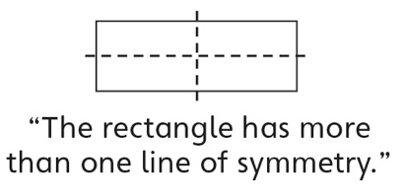
Observations/Documentation

