Making Pictures and Designs with 2-D Shapes Behaviours/Strategies
- Student constructs a composite picture/design  with 2-D shapes, but shapes do not touch.  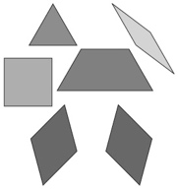 | - Student constructs a composite picture with  2-D shapes, but uses only one shape.  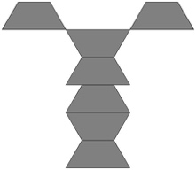 | - Student constructs a composite picture with 2-D  shapes, but each shape represents a part of an  object (shapes are not combined).  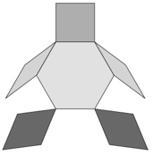
Observations/Documentation
- Student constructs a composite picture with  2-D shapes and combines shapes to represent parts of the picture, but cannot identify the shapes used.  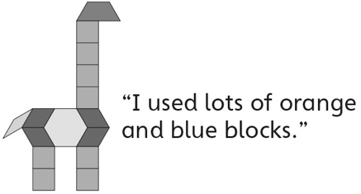 | - Student constructs a composite picture/design  with 2-D shapes, but struggles to explain how it was created.  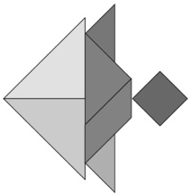 | - Student successfully constructs a composite  picture/design with 2-D shapes, explains how it  was created, and identifies shapes used.
Observations/Documentation

