Soccer Training Camp
Master 46a

Soccer players Jada and Erika train together.
They do the same routine at the same time:
Jada | Erika
2 minutes |  | 2 minutes
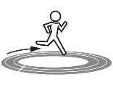 10 minutes |  | 10 minutes
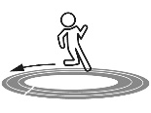 5 minutes |  | 5 minutes
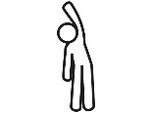 5 minutes |  | 5 minutes
2 minutes |  | 2 minutes
5 minutes |  | 5 minutes
2 minutes |  | 2 minutes

Soccer Training Camp
Master 46b

The code for the routine is:
Jada | Erika
JJ2, L$↺$10, L$↻$5, 5SB, C2, JR5, S2 | JJ2, L$↺$10, L$↻$5, 5SB, C2, JR5, S2

You are their coach at training camp. Add breaks and 2 more exercises per player. The players should perform the same exercise at the same time at least twice, and finish at the same time.
Alter the code.
Jada | Erika

Alter the code for the coach’s challenge. Use Master Z to help.
Jada | Erika

