Measurement Recording Sheet
Master 8a

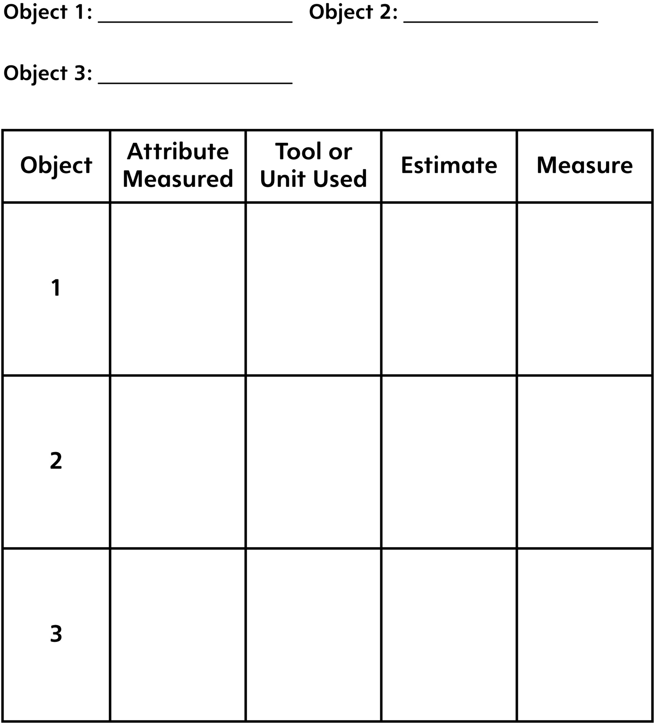

Measurement Recording Sheet
Master 8b

Write one thing that is important to remember when measuring:
Length:

Distance Around:

