Measuring Behaviours/Strategies
- Student estimates objects by  length and distance around  using non-standard units, but  estimates are unreasonable. | - Student chooses an attribute, but  does not select an appropriate non-standard unit to measure.  “I will use the pan balance to  measure length.” | - Student measures objects using  non-standard units, but focuses on one attribute.  “I like to measure length.”
Observations/Documentation
- Student measures objects by  length and distance around using non-standard units, but leaves gaps or overlaps.  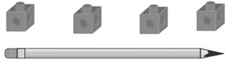 | 5. Student successfully measures  objects by length and distance around using non-standard units, but does not include a unit  with the measure.  “Its distance around is 6.” | 6. Student successfully measures  objects by length and distance around using non-standard units.
Observations/Documentation

