Measuring Length in Metres Behaviours/Strategies
- Student struggles to estimate length using a  standard unit (centimetre) and the estimate is  extreme or unreasonable. | - Student measures length using a standard unit (centimetre), but lines up 1 on the ruler with the end of the object being measured.  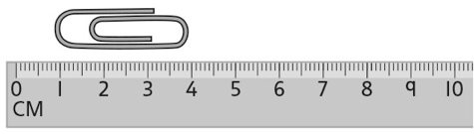 | - Student measures length using a standard unit  (centimetre), but counts tick marks instead of  the units between the marks.
Observations/Documentation
- Student measures length using a standard unit (centimetre), but struggles to deal with part of a centimetre (ignores leftover).  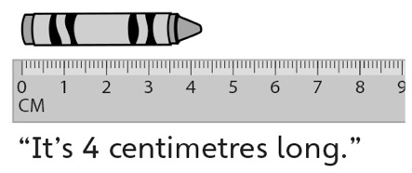 | - Student measures length using a standard unit (centimetre), but forgets to include the unit when stating the measure.  “It is 7 long.” | - Student successfully estimates and measures  length using a standard unit (centimetre) and  includes units with measures.  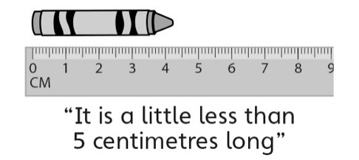
Observations/Documentation

