Choosing an Appropriate Unit and Estimating Length Behaviours/Strategies
- Student chooses an object, but  struggles to select an appropriate  standard unit to measure length.  “I will use centimetres to measure the length of the  teeter-totter.” | - Student selects an appropriate  standard unit and tool to measure length, but cannot justify choice.  “I just know metres is what  I should use.” | - Student selects an appropriate  standard unit, but the estimate is  extreme or unreasonable. | - Student successfully selects an  appropriate standard unit to  measure length, and estimates are reasonable.
Observations/Documentation
Measuring Length in Standard Units Behaviours/Strategies
1. Student measures length using  standard units, but does not line  up the object with the baseline of  the measuring tool.  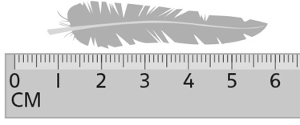 | 2. Student measures length using  standard units, but struggles to  iterate the measuring tool. | 3. Student measures length using  standard units, but forgets to  include the unit when stating the  measure or ignores leftover.  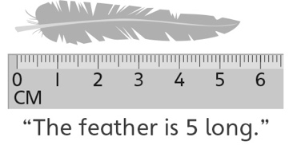 | 4. Student successfully measures  length using standard units and  includes units with measures.  “The feather is a little more than  5 centimetres long.”
Observations/Documentation

