Counting On and Counting Back Behaviours/Strategies
- Student begins with start number, but omits  numbers when saying number name sequences forward and backward.  “11, 12, 14, 16, 17, 18” | - Student begins with start number, but mixes up the order when saying number name sequences forward and backward.  “11, 12, 14, 13, 15, 16” | 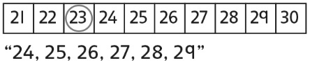  - Student says the number name sequences forward and backward from a given number and relies on the hundred chart or class number line.
Observations/Documentation
- Student says the number name sequences  forward and backward from a given number, but struggles to bridge tens.  “47, 48, 49, 30, 31” | - Student says the number name sequences  forward and backward from a given number and successfully bridges tens, but does not recognize patterns in the number name sequence.  “I don’t see any patterns.” | - Student says the number name sequences forward and backward from a given number and uses number patterns to bridge tens and hundreds.
Observations/Documentation

