Skip-Counting by 2s Game Cards
Master 19a

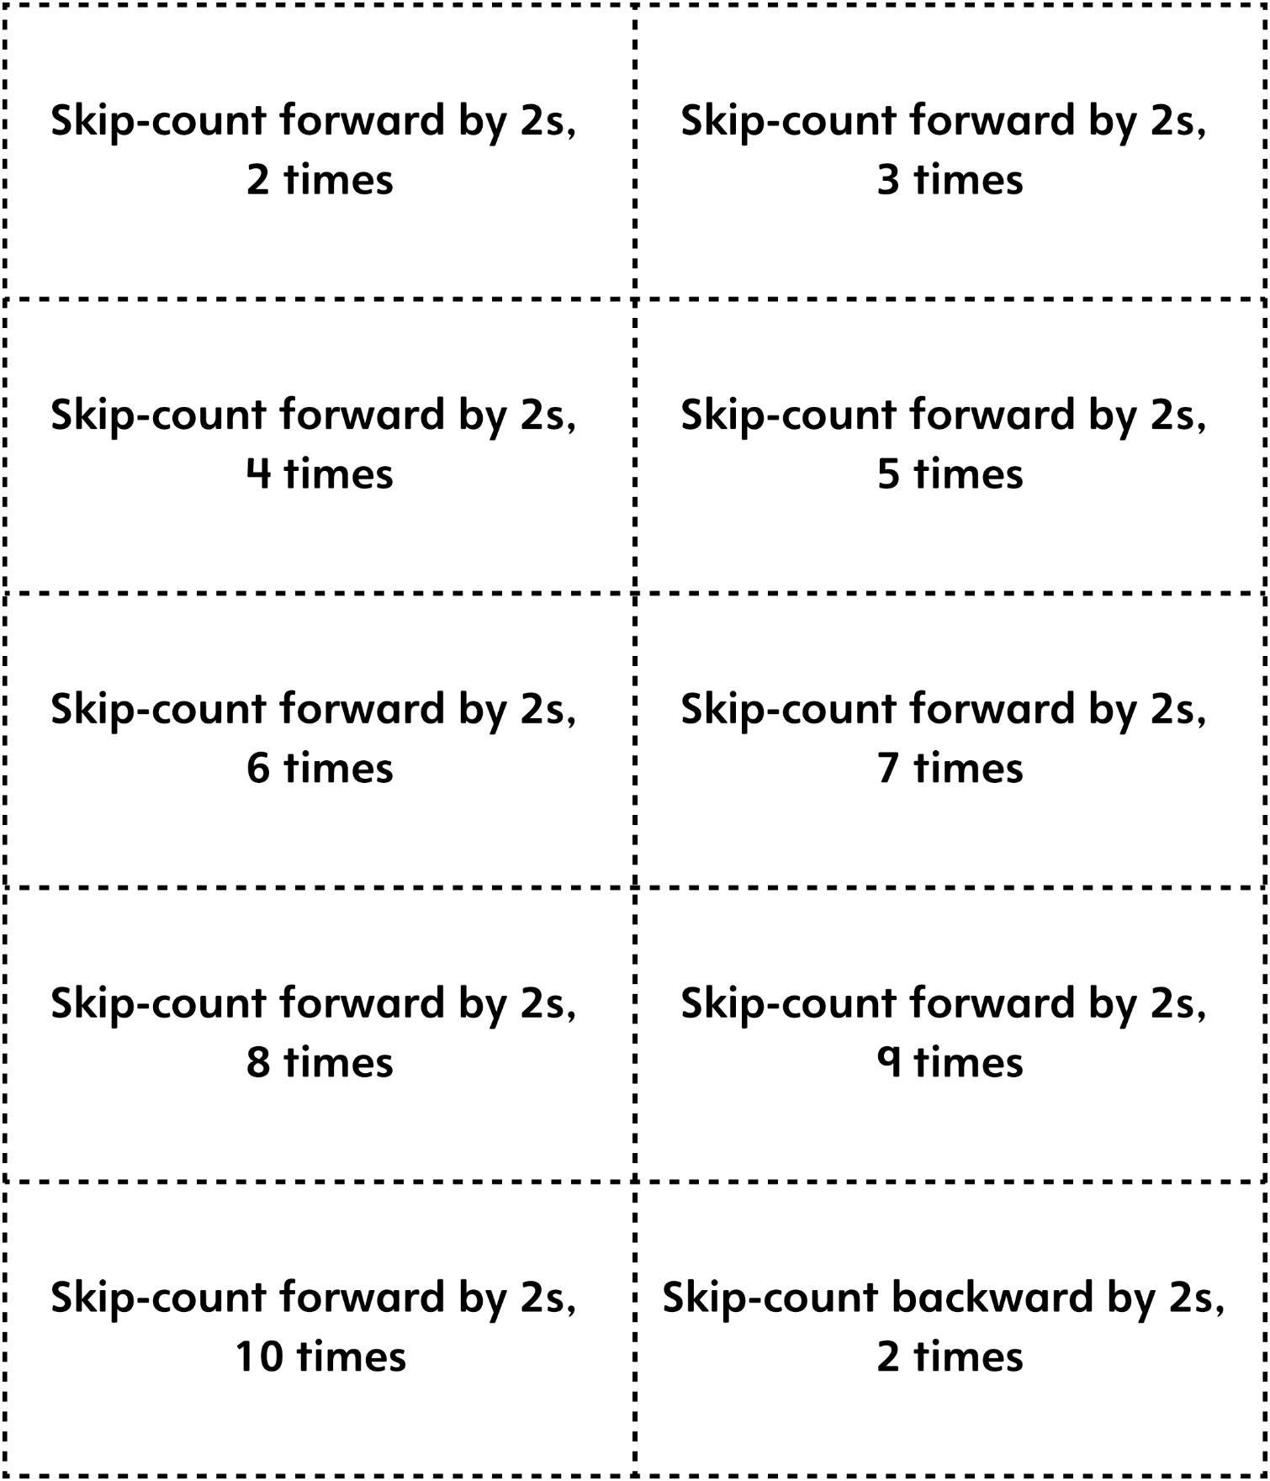

Skip-Counting by 2s Game Cards
Master 19b

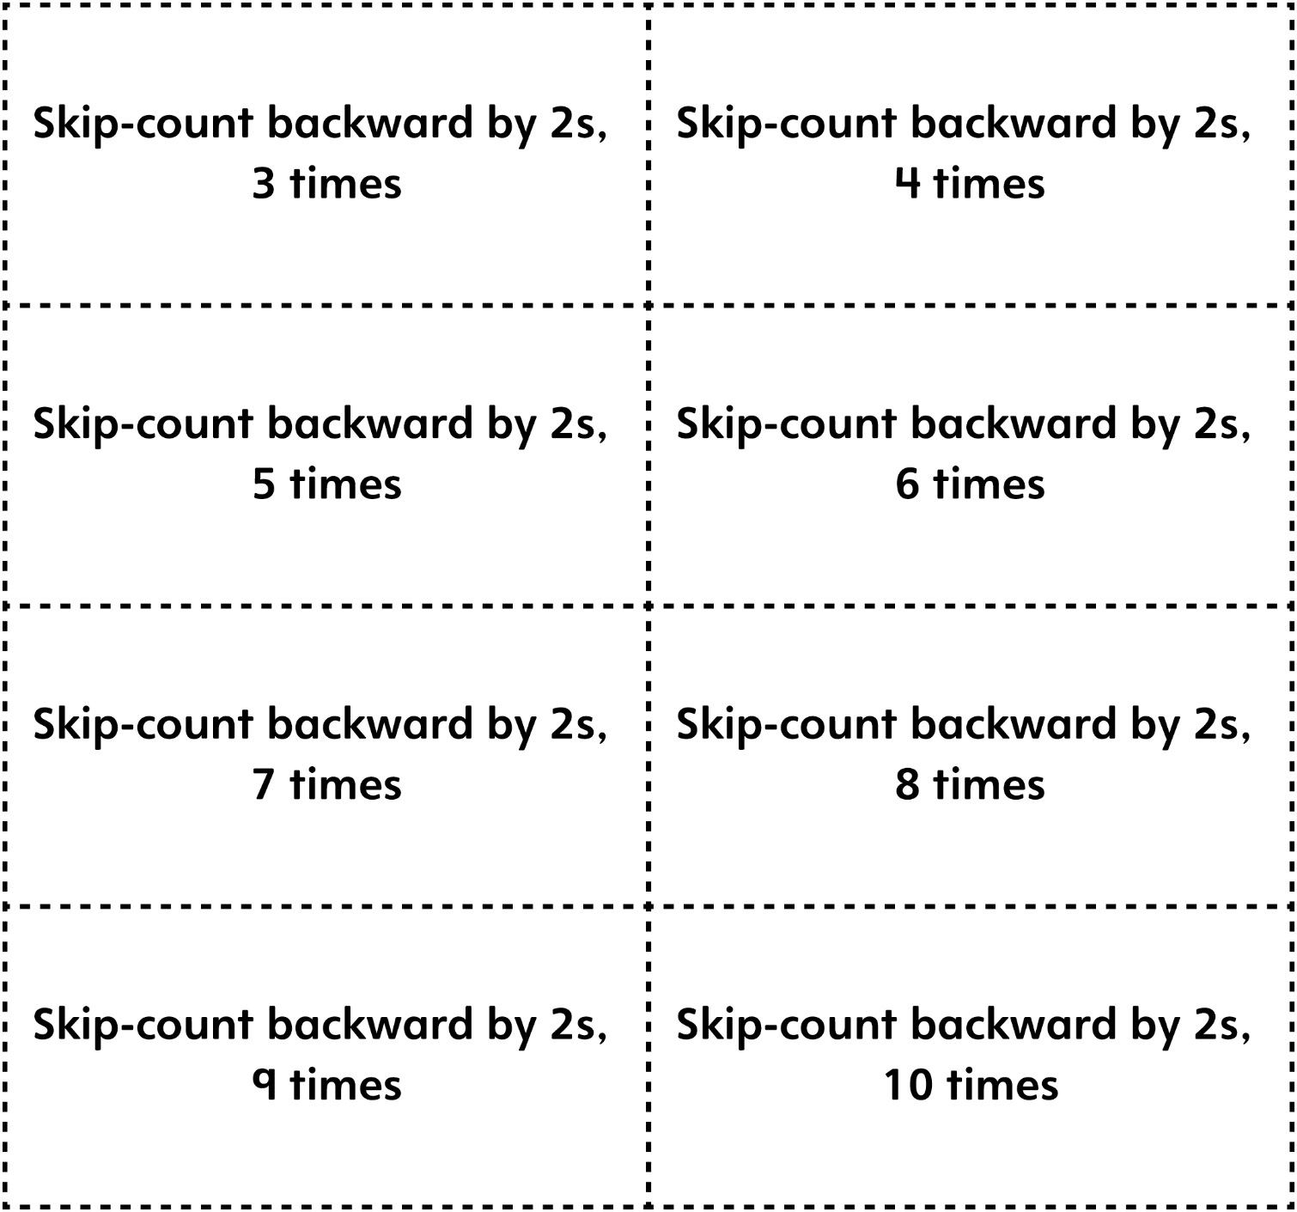

Skip-Counting by 5s Game Cards
Master 19c

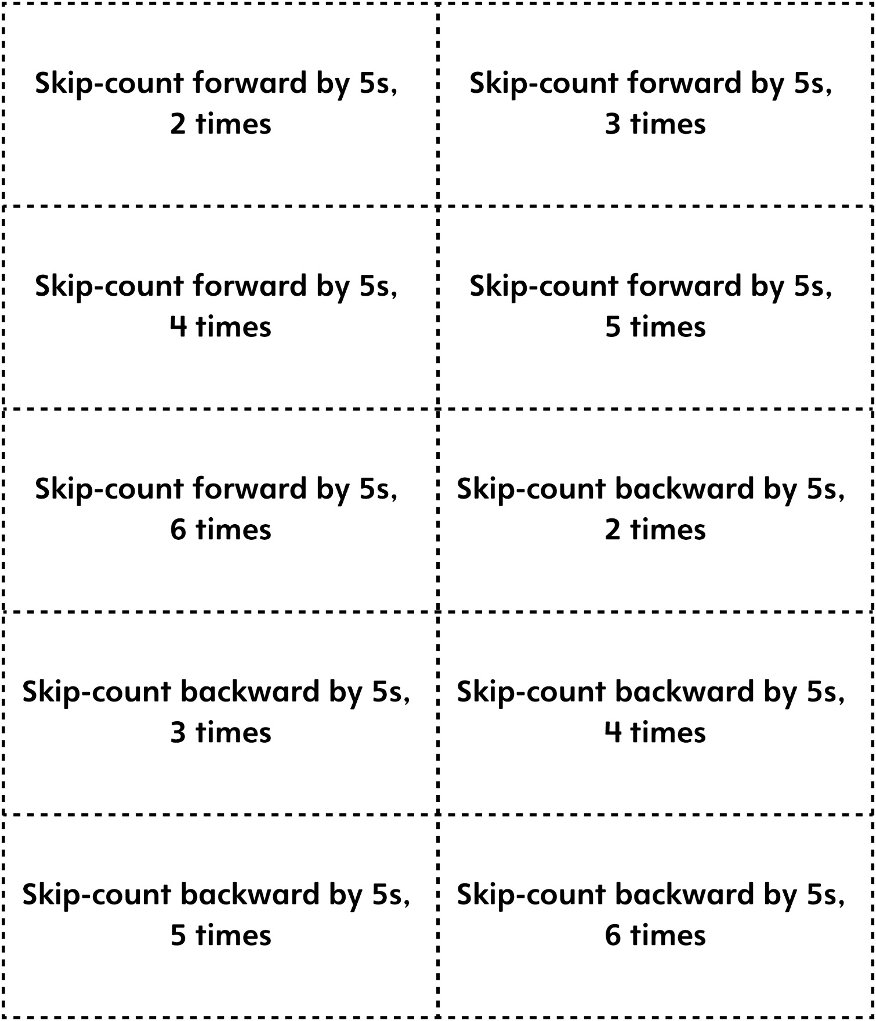
Skip-Counting by 5s Game Cards
Master 19d

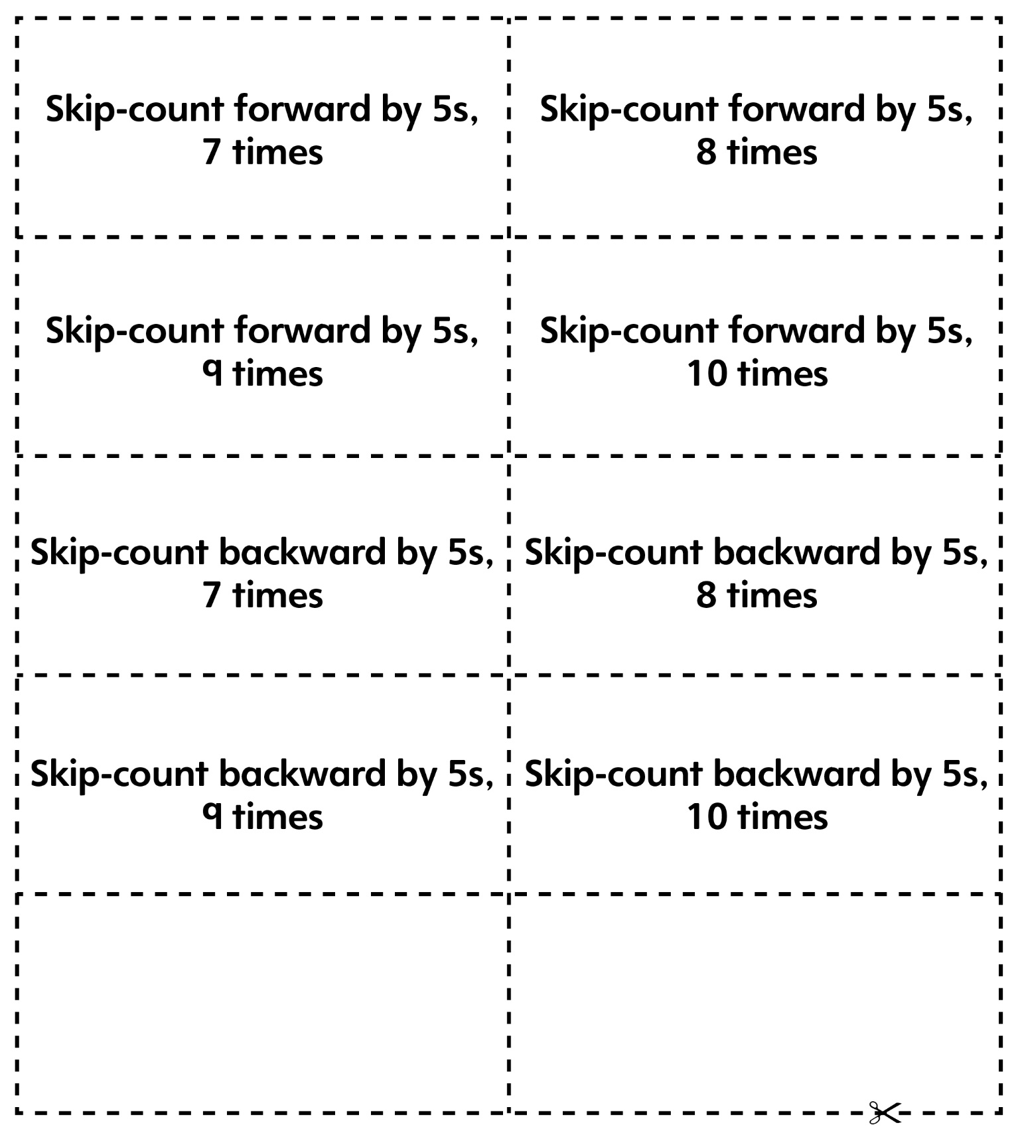

Skip-Counting by 10s Game Cards
Master 19e

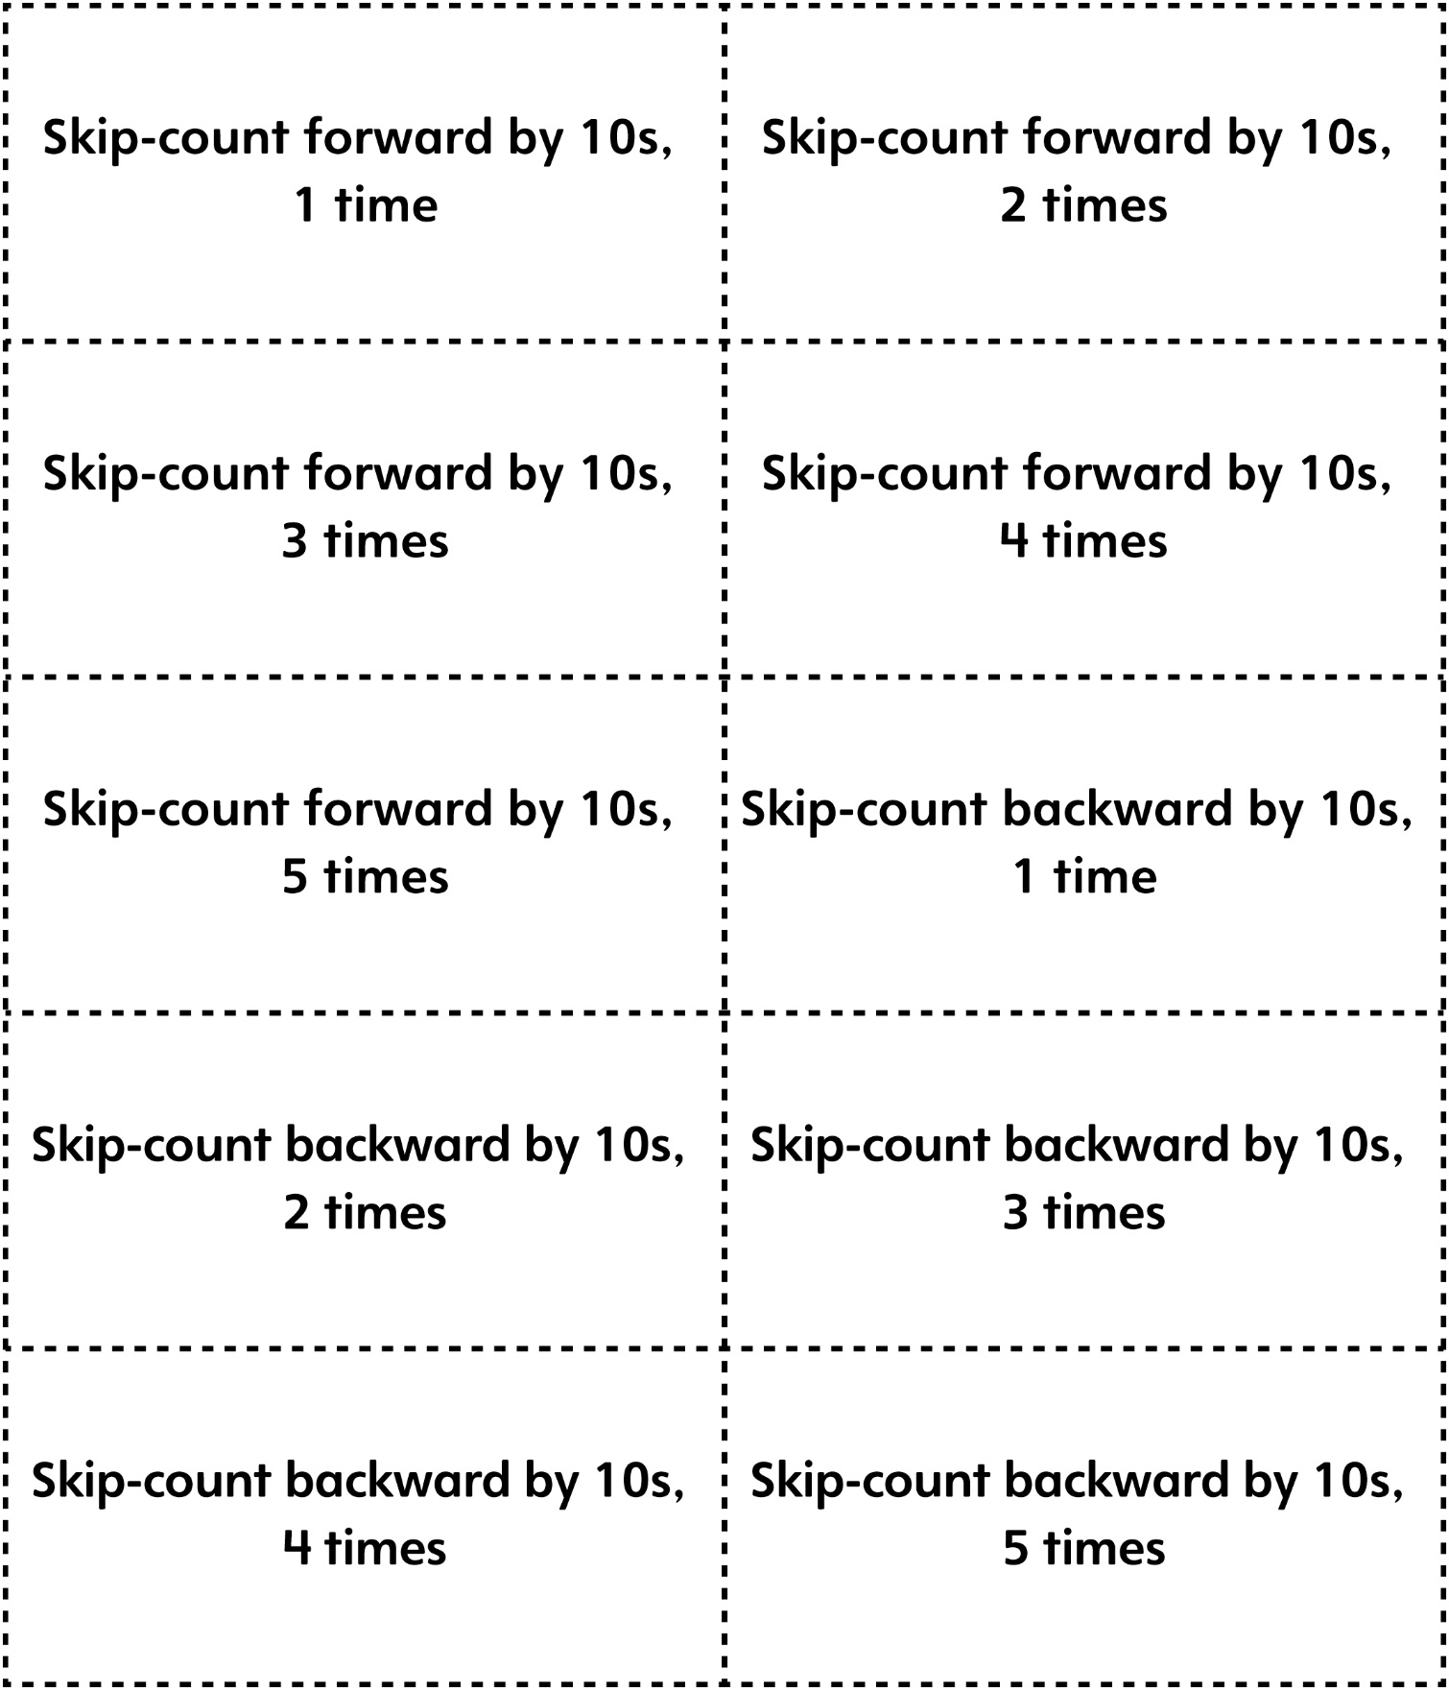
Skip-Counting by 10s Game Cards
Master 19f

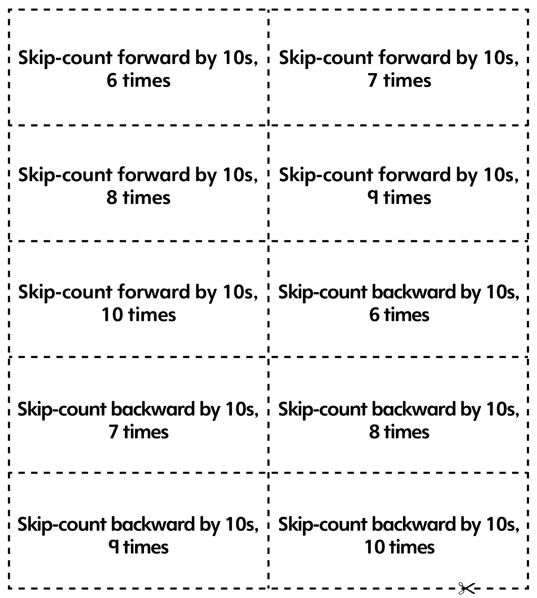
Skip-Counting by 20s Game Cards
Master 19g

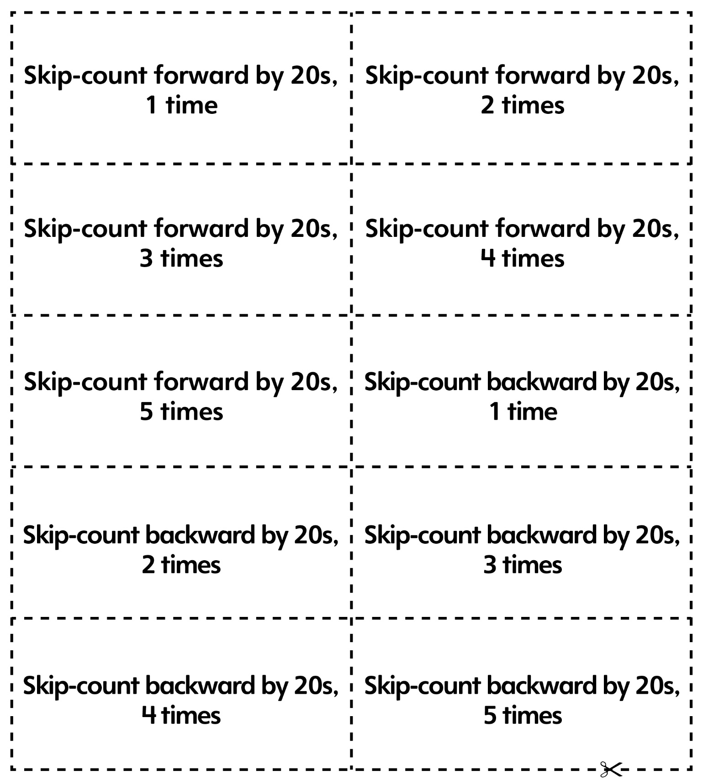

Skip-Counting by 25s and 50s
Game Cards
Master 19h

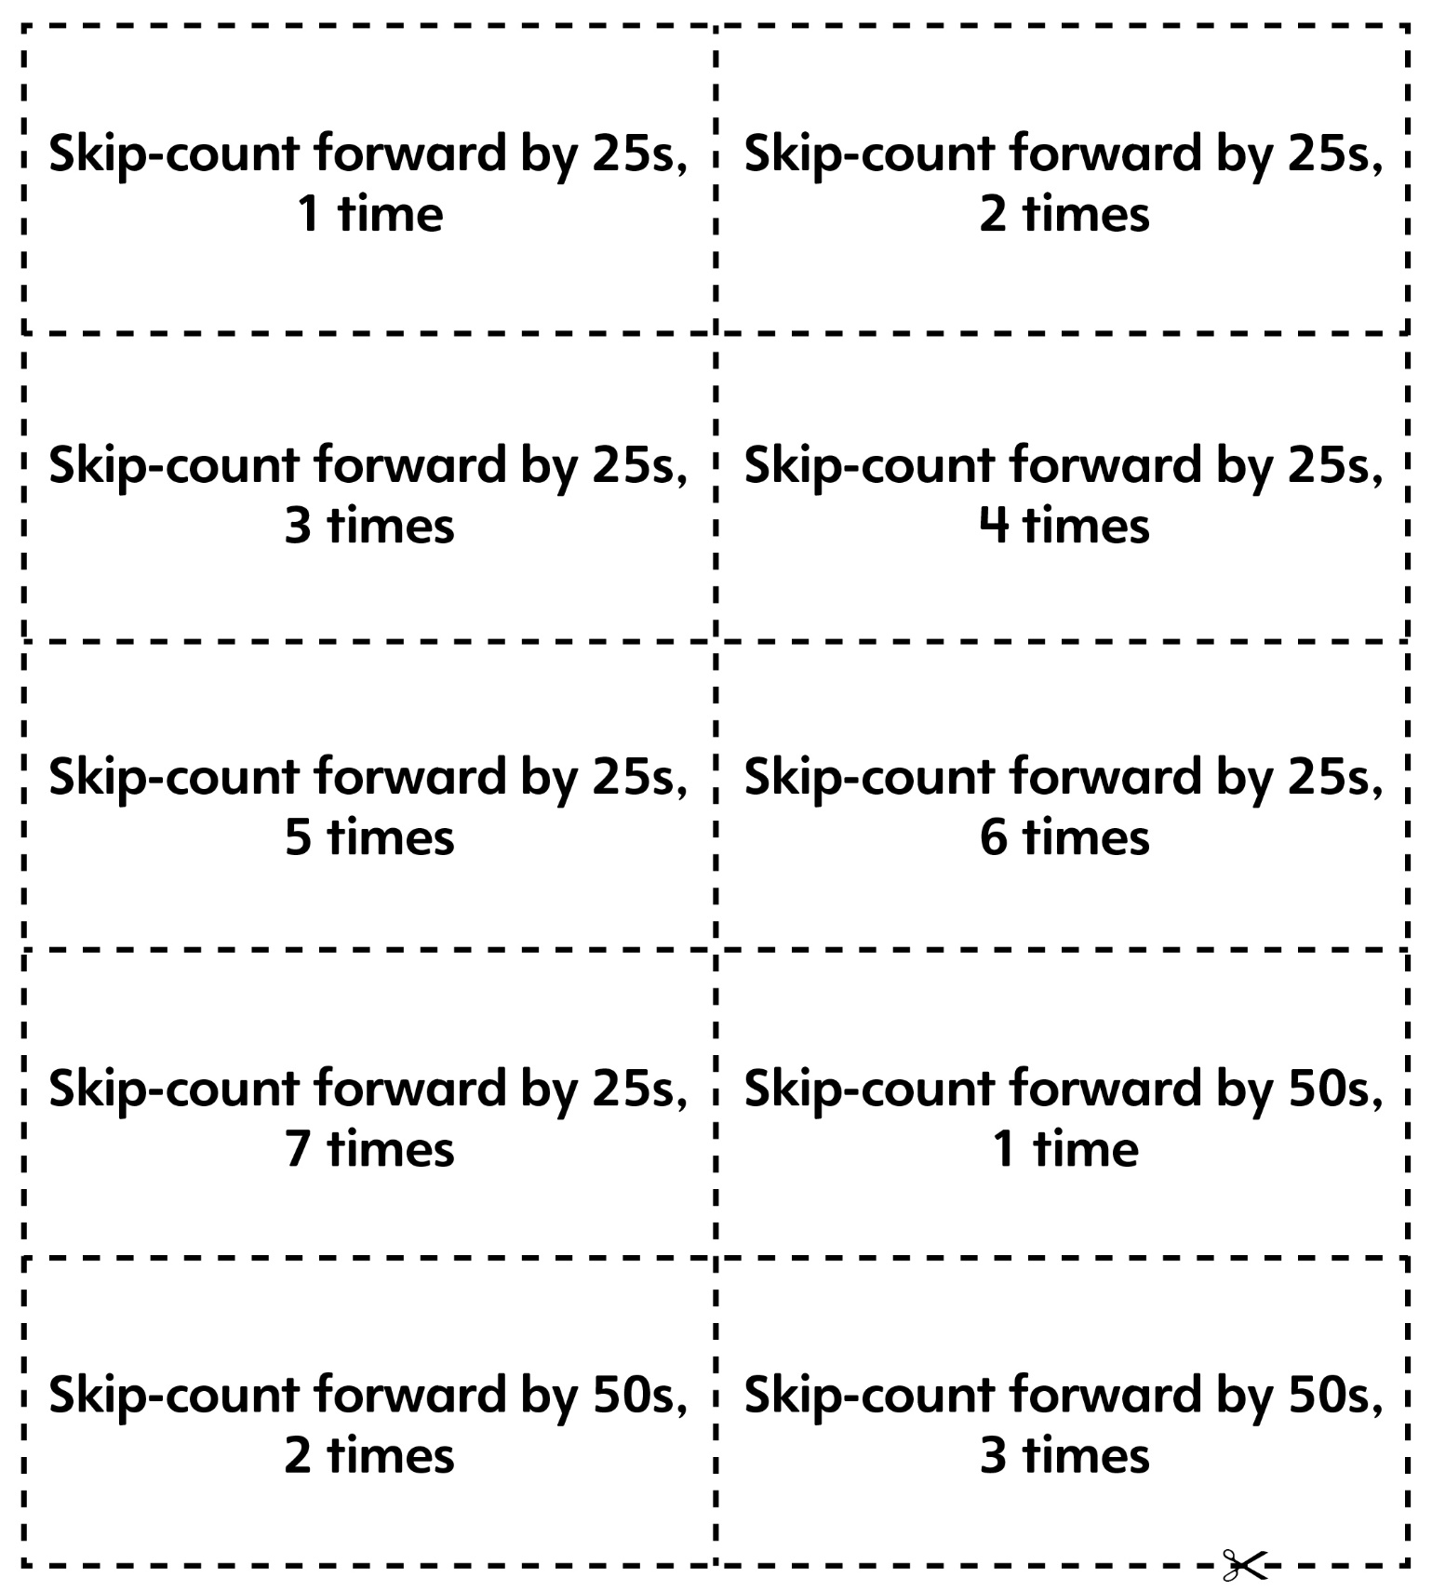
Skip-Counting Game Cards
Master 19i
(Blank Cards)

