Counting On and Back Behaviours/Strategies
- Student uses correct start number, but omits numbers or mixes up the order when saying the number name sequences forward and backward.  “11, 12, 14, 16, 17” | - Student says the number name  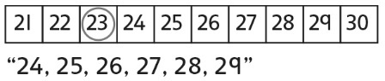  sequences forward and backward from a given number, but relies on the hundred chart. | - Student says number name sequences forward and backward from a given number, but struggles to bridge tens or hundreds.  “Ninety-nine, one-ten, one-eleven” | - Student says the number name  sequences forward and backward from a given number and uses number patterns to bridge tens and hundreds.
Observations/Documentation
Skip-Counting Forward and Backward Behaviours/Strategies
- Student uses correct start number, but mixes up the numbers or omits numbers when skip-counting forward and backward by factors of 10.  “5, 10, 20, 25, 35” | - Student skip-counts forward by  factors of 10, but struggles to skip-count backward.  “It is much easier to skip-count  forward.” | - Student skip-counts forward and  backward by factors of 10, but uses fingers or the hundred chart to help.  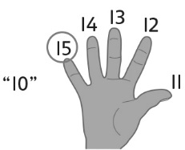 | - Student fluently skip-counts forward and backward by multiples of 5 (e.g., 5, 10, 20, 25, 50) to 200.  "80, 60, 40, 20, 0"  "50, 75, 100, 125, 150"  "200, 150, 100, 50, 0"
Observations/Documentation

