Number Relationships Behaviours/Strategies
- Student partitions quantities into groups of 2, but struggles to identify even and odd numbers.  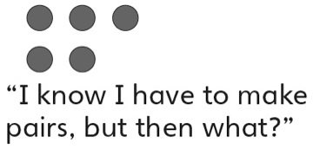 |  | - Student compares and orders quantities using one-to-one matching or counting (models numbers with concrete materials).  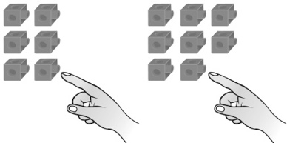 |  | - Student compares and orders written numbers using benchmarks.  “I know 25 is less than 30  and 39 is greater than 30.  So, 39 is greater than 25.”
Observations/Documentation
- Student determines how many more/less by grouping (groups cubes to make trains and then aligns the trains).  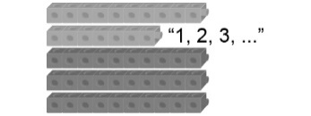 |  | - Student determines how many more/less using counting (finds distance between numbers on a number line or hundred chart).  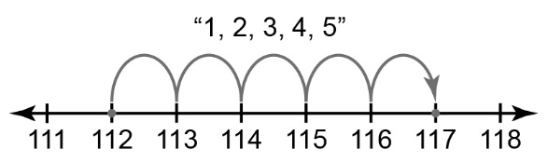 |  | - Student performs number relationship tasks with ease and communicates thinking using math language.
Observations/Documentation

