Partitioning into Equal-Sized Units Behaviours/Strategies
- Student counts objects by 1s, but struggles to partition objects into equal-sized units (not all units are equal). | - Student partitions objects into  equal-sized units, but mixes up the skip-counting sequence or does not know the number to skip-count by.  “5, 10, 20, 25, 35” | - Student partitions into and skip-counts by equal-sized units, but does not include the leftovers in the total.  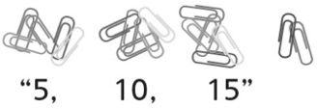 | - Student partitions into and skip-counts by equal-sized units, but  continues to skip-count by the same number to count the leftovers.  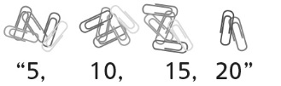
Observations/Documentation
- Student partitions into and skip-counts by equal-sized units, but  does not recognize that the results will be the same when counted in different ways.  “There were 17 when I  grouped in 5s.  Let’s see how many when I  group in 2s.” | - Student partitions into and skip-counts by equal-sized units, but  does not realize that increasing  the number of sets decreases the number of objects in each set.  “There should be more groups  of 10 than groups of 5 because  10 is bigger.” | - Student partitions into and  skip-counts by equal-sized units,  but does not recognize that the  number of groups of 5 is often  double the number of groups of 10 (i.e., does not see equal-sized sets as units within a larger set).  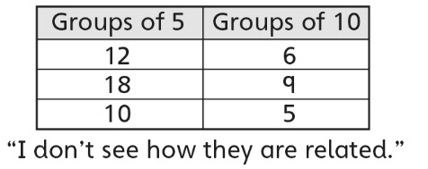 | - Student successfully partitions into and skip-counts by equal-sized units and recognizes relationships among the different unit sizes.
Observations/Documentation

