Building Numbers to 200 Behaviours/Strategies
- Student adds unit cubes to show number rolled but has more than 10 cubes in the Ones column.  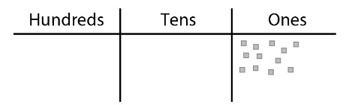 |  | - Student trades unit cubes for rods but isn’t sure how many ones make a ten.  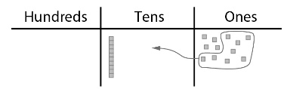  “I have a lot of cubes, so maybe I should trade some for a red.” |  | - Student trades cubes for rods but has more than 10 rods in the Tens column.  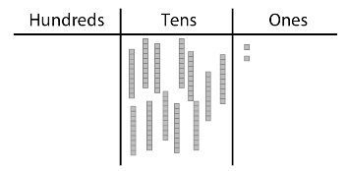
Observations/Documentation
- Student trades rods for a flat but isn’t sure how many tens make a hundred.  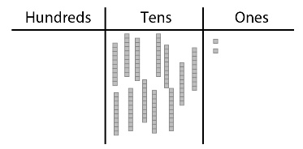  “I know I have to trade, but I don’t think I have enough rods yet.” |  | - Student understands the relationships among hundreds, tens, and ones but struggles to name the number modelled.  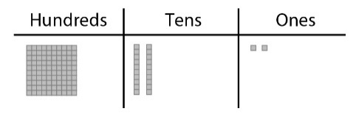  “I have 1 hundred, 2 tens, and 2 ones. What number is that?” |  | - Student understands the relationships among hundreds, tens, and ones and relates the model to a number.  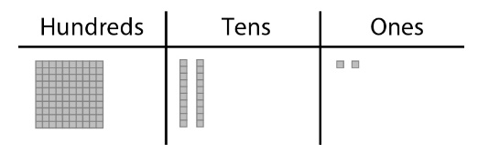  “The model shows 122.”
Observations/Documentation

