Decomposing Numbers Behaviours/Strategies
- Student decomposes number into units of tens and leftover ones, but has more than 10 cubes in the Ones column or confuses the number of tens with the number of cubes.  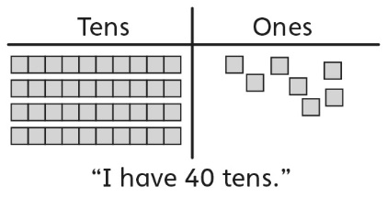 | - Student decomposes number into units of tens and leftover ones, and uses cubes to determine how many more ones are needed to make another ten.  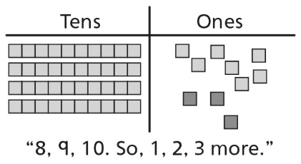 | - Student decomposes number into units of tens and leftover ones, but is unable to determine 10 more/less without counting. | - Student decomposes number into units of hundreds, tens, and leftover ones, determines how many more tens are needed to make another hundred, and finds 10 more/less without counting.  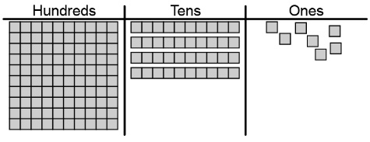  “10 more is 157. 10 less is 137.”  “6 more tens are needed to make another hundred.”
Observations/Documentation
Partitioning into Equal-Sized Units Behaviours/Strategies
- Student counts objects by 1s, but  struggles to partition objects into  equal-sized units (not all units are equal).  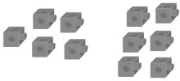 | - Student partitions into and skip-counts by equal-sized units, but  continues to skip-count to count  the leftovers.  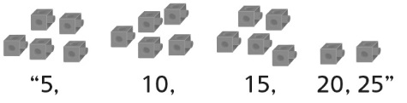 | - Student partitions into and skip-counts by equal-sized units, but  does not recognize relationships  among the different unit sizes. | - Student successfully partitions into and skip-counts by equal-sized units and recognizes relationships among the different unit sizes.
Observations/Documentation

