Partitioning Wholes into Equal Parts Behaviours/Strategies
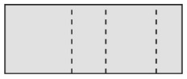  - Student takes an item, but struggles to partition it into equal parts, and parts are not equal. | - Student partitions wholes into 2 and 4 equal  parts, but struggles to cut or fold wholes into  other numbers of equal parts (e.g., 3, 6, 8). | - Student partitions wholes into equal parts, but  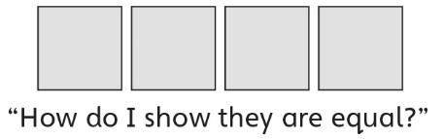  struggles to prove that they are equal.
Observations/Documentation
- Student partitions wholes into equal parts, but  struggles to name the unit (does not know  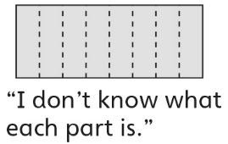  fraction words). | - Student partitions wholes into equal parts and  names the unit, but cannot relate the size of  parts to the number of equal parts in a whole. | - Student successfully partitions wholes into  equal parts, names the unit, and relates the  size of parts to the number of equal parts in a  whole.
Observations/Documentation

