Comparing Fractions of a Whole Behaviours/Strategies
- Student takes a square, but  struggles to partition it into equal  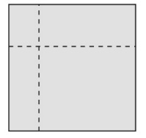  parts, and parts are not equal. | - Student partitions wholes into  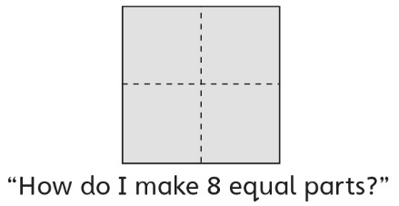  2 and 4 equal parts, but struggles to partition whole into 8 equal parts. | - Student partitions wholes into  equal parts, but struggles to prove that they are equal.  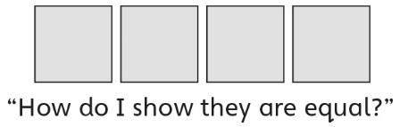 | - Student partitions wholes into equal parts, but struggles to name the unit (does not know fraction words).  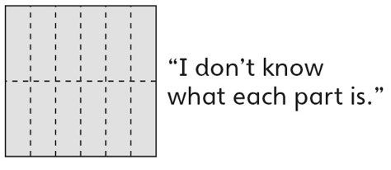
Observations/Documentation
- Student partitions wholes into  equal parts and names the unit,  but does not realize that dividing  a whole into more equal parts  produces smaller parts. | - Student partitions wholes into equal parts and names the unit, but does not realize that dividing a whole into smaller parts produces more parts. | - Student partitions wholes into  equal parts and names the  unit, but struggles to use math  language to compare parts. | - Student successfully partitions  wholes into equal parts, names  the unit, and relates the size of the parts to the number of equal parts in a whole.
Observations/Documentation

