Partitioning Sets Behaviours/Strategies
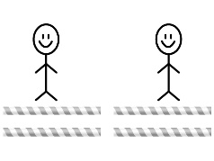  - Student shares items equally when there are no leftovers.  “I shared 4 straws and  each person got 2 straws.” | 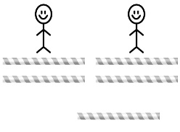  - Student shares some items equally but ignores the leftover.  “I shared 5 straws and  each person got 2 straws.” | - Student shares some items equally but is not sure how to partition the leftover.  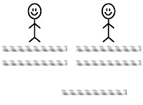  “I’m not sure how to divide  the leftover straw.”
Observations/Documentation
- Student shares items equally, including leftovers, but cannot use fractions to name the amount each sharer gets.  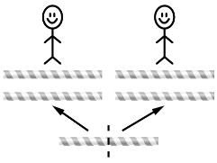  “Each person gets 2 and  a bit. Or, each person gets  three.” | - Student shares items equally, including leftovers, and uses fractions to name the amount each sharer gets.  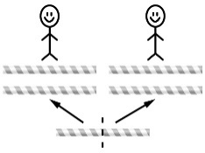  “Each person got two and  one-half straws.” | - Student shares items equally, including leftovers, and recognizes that one-third and two-sixths of the same whole are equal.  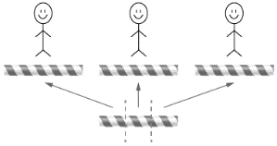  “Each person got one and  one-third straws. If I cut  the leftover straw in sixths,  each person gets one and  two-sixths straws.”
Observations/Documentation

