Comparing Numbers Using Benchmarks on a Number Line Behaviours/Strategies
- Student takes a paper strip, but is unable to  make benchmark folds (e.g., folds the paper  randomly or struggles to fold the strip in half). | - Student makes benchmark folds, but struggles to label folds with benchmark numbers. | - Student correctly shows benchmark numbers on the number line, but cannot compare numbers to identify the closer ten.  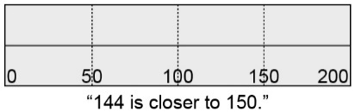
Observations/Documentation
- Student successfully compares most numbers  using benchmarks, but struggles when the ones digit of the number is 5.  “I don’t know what number 85 is closer to.” | - Student successfully compares numbers using benchmarks, but struggles to write the number in its approximate location on the number line.  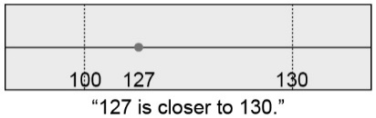 | - Student successfully compares numbers using  benchmarks and writes numbers in their  approximate locations on the number line.
Observations/Documentation

