Number Relationships Behaviours/Strategies
- To decompose two-digit numbers  into parts, student counts out  counters and then arranges them  in two groups. | - To decompose two-digit numbers  into parts, student chooses a part  and then counts on or back with  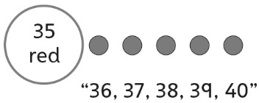  counters to find the other part. | - Student decomposes two-digit  numbers into parts, but struggles  to compose two-digit numbers  from parts (unable to take jumps  of different sizes on a number line). | 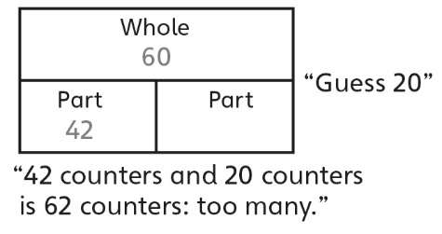  - To find a part given the whole and another part, student guesses and then uses counters to check.
Observations/Documentation
- To find a part given the whole and another part, student counts on or back with counters or fingers.  “43, 44, 45, ..., 58, 59, 60” | - Student shows benchmark  numbers on the number line, but  struggles to name a number closer to the given ten.  “136 is between 130 and 140, but I don’t know which number it is closer to.” | - Student shows benchmark numbers on the number line, but struggles to name the number that is the same distance from both benchmarks.  “I don’t know what number is the  same distance from 180 as  from 190.” | - Student successfully demonstrates an understanding of number relationships by using efficient strategies (skip-counting, mental math) to answer cards of all types.
Observations/Documentation

