**Domino Cards**

**Master 75a**

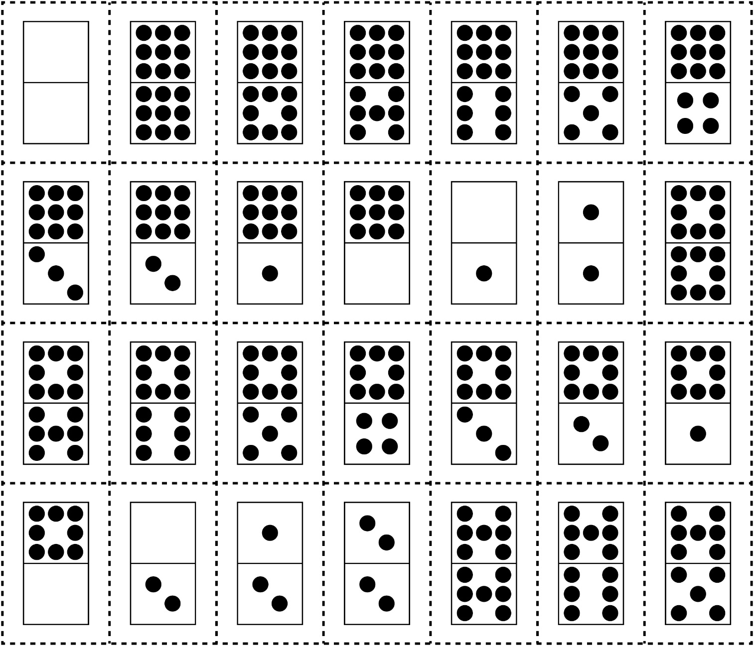

**Domino Cards**

**Master 75b**

