**Story Problems 2**

**Master 80a**

**(Whole Unknown)**

**Note:** Story Problem Card 3 is for use as an accommodation.

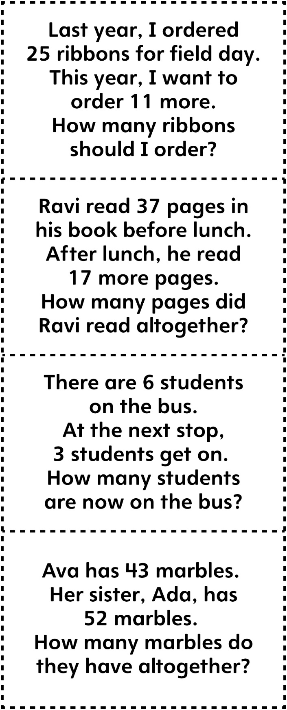



**Story Problems 2**

**Master 80b**

**(Whole Unknown)**

