How Many? Objects
Master 108a

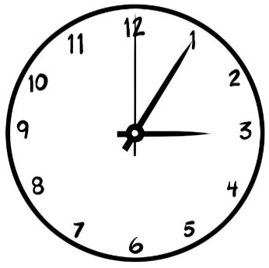

1 clock has 3 hands.

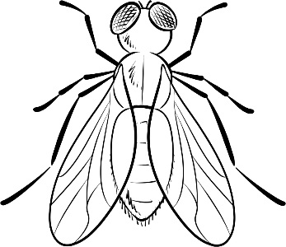

1 insect has 6 legs.

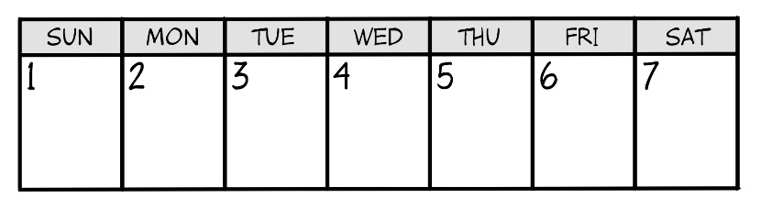

1 week has 7 days.

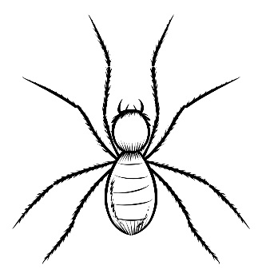

1 spider has 8 legs.

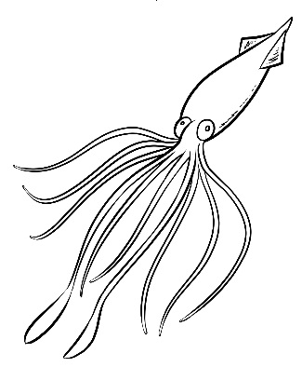

1 squid has 10 limbs.

How Many? Objects
Master 108b

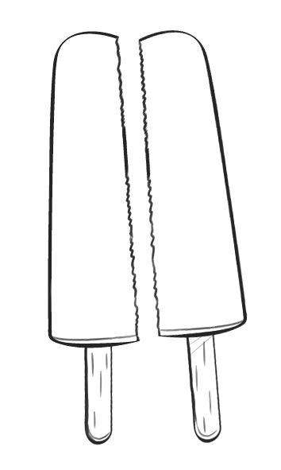

1 popsicle has 2 halves.

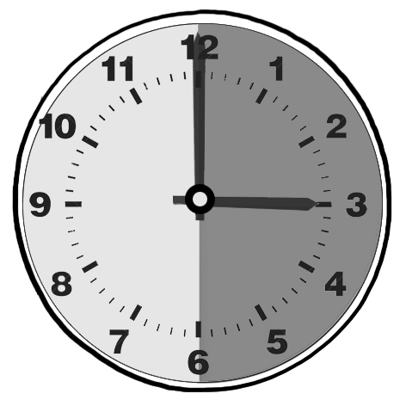

1 hour has 2 halves.

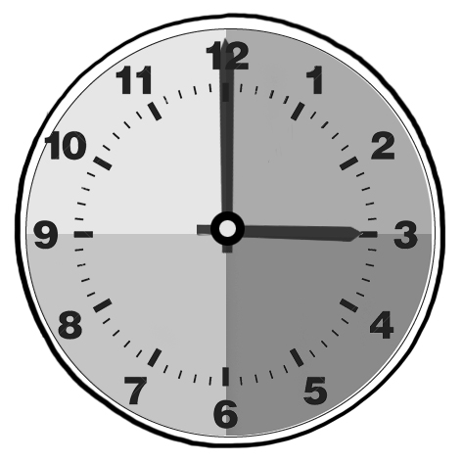

1 hour has 4 fourths.

1 sandwich has 4 fourths.

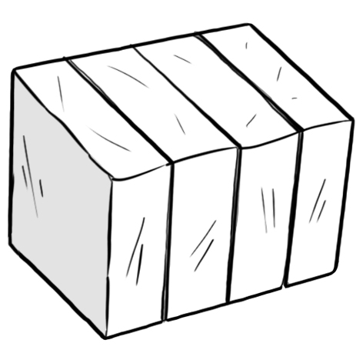
1 block of modelling clay has 4 fourths.

