Repeated Addition Problems
Master 111a

Side A  There are 2 shoes in a pair.  How many shoes are in 4 pairs?  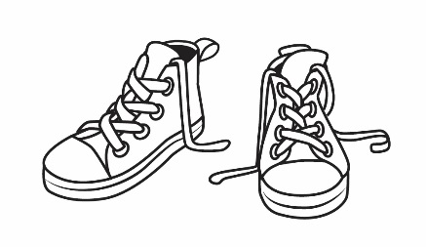 | Side A  There are 3 wheels on a tricycle.  How many wheels are on 4 tricycles?  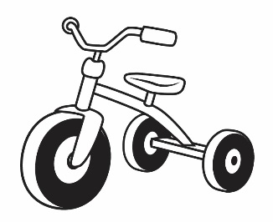
Side A  There are 4 wheels on a car.  How many wheels are on 3 cars?  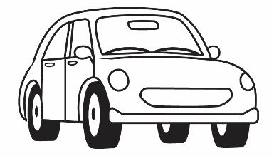 | Side A  A glove has 5 fingers.  How many fingers do 2 gloves have?  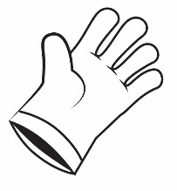
Side A  A guitar has 6 strings.  How many strings do 2 guitars have?  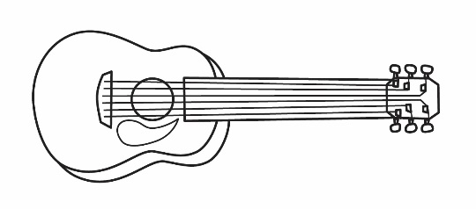 | Side A  There are 3 sides on a triangle.  How many sides are on 3 triangles?
Side B  A star has 5 points.  How many points do 5 stars have? | Side B  A wolf has 2 ears.  How many ears do 7 wolves have?  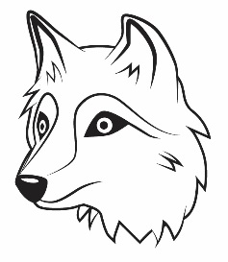
Repeated Addition Problems
Master 111b

Side B  There are 4 leaves on a four-leaf clover.  How many leaves are on 6 four-leaf clovers?  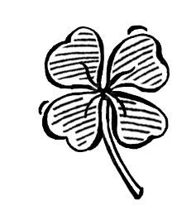 | Side B  A muffin tin holds 6 muffins.  How many muffins do 5 tins hold?  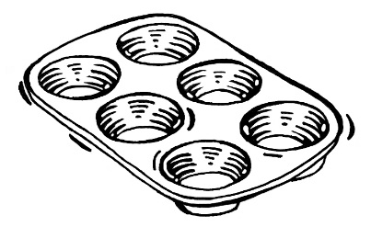
Side B  There are 7 days in a week.  How many days are in 4 weeks?  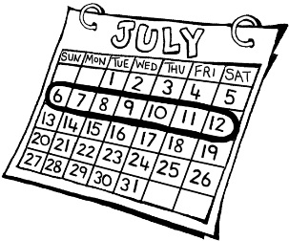 | Side B  A scorpion has 8 legs.  How many legs do 3 scorpions have?  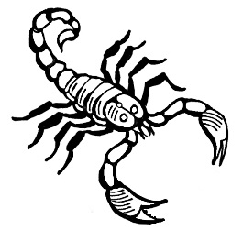
Side B  A stop sign has 8 sides.  How many sides do 2 stop signs have?  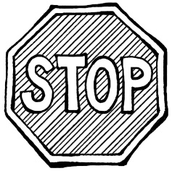 | Side B  A baseball team has 9 players.  How many players do 3 teams have?  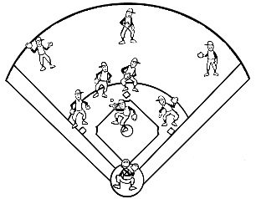
Side B  Wieners come in packages of 10.  How many wieners are in 3 packages?  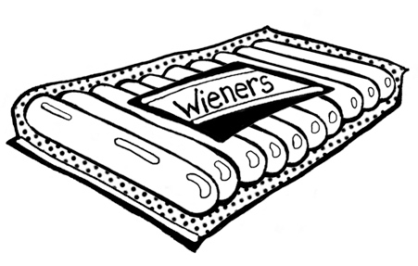 | Side B  Eggs come in cartons of 12.  How many eggs are in 2 cartons?  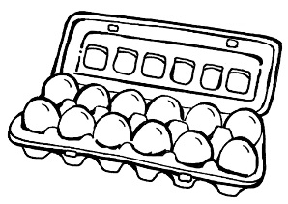

Repeated Addition Problems
with Fractions
Master 111c

MU Card 9  A tennis court has two halves.  How many halves do 3 tennis courts have?  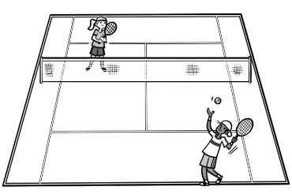 | MU Card 9  A block of butter has 4 fourths.  How many fourths do 5 blocks of butter have?  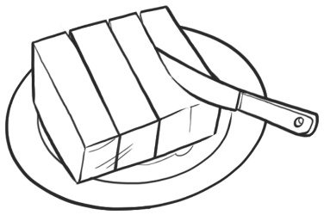
MU Card 9  $5 is one-half of $10.  How many $5 bills would make $30?  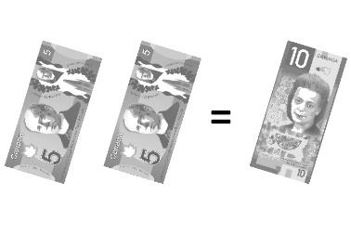 | MU Card 9  One quarter is one-fourth of a dollar. How many dollars do you have if you have 16 quarters?  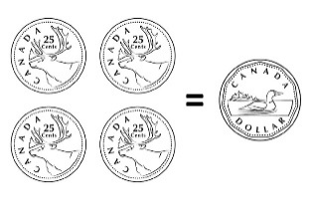
MU Card 9  A trapezoid is one-half of a hexagon.  How many hexagons would 6 trapezoids make?  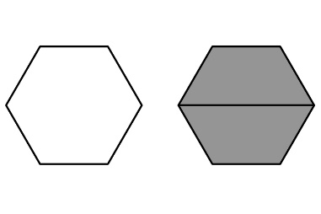 | MU Card 9  In basketball practice, Tyrell runs across half of the court. If he runs across half the court 6 times, how many full courts does he run?  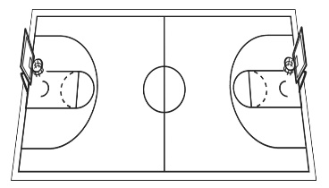
MU Card 9  A sock is one-half of a pair. If you have 8 socks, how many pairs do you have?  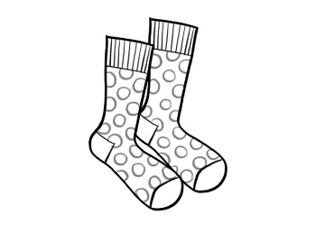 | MU Card 9  A glove is one-half of a pair. If you have 10 pairs, how many gloves do you have?  