Division Problems
Master 113a

Equal-Grouping Problems
Priya has 12 ride tickets.  Each ride is 3 tickets.  How many rides can Priya  go on? | Ben has 10 scoops of ice cream. He puts 2 scoops on a cone. How many ice cream cones can he make?
Mother robin brought 8 worms to the nest to feed her babies. Each baby gets 2 worms.  How many babies can she feed? | Twelve children are in line for the Ferris wheel. Each car holds 4 children. How many cars do they need?

Equal-Sharing Problems
At summer camp, 9 girl campers need to share 3 tents equally. How many girls will be in each tent? | Ben has 10 strawberries to share equally among 5 fruit smoothies. How many strawberries can he put in each?
12 students want to divide themselves into 4 equal teams to play a game. How many students will be on each team? | Felix has 6 toy cars to share equally among 3 loot bags. How many toy cars will be in each bag?

Division Problems
(Accommodation)
Master 113b

Equal-Grouping Problems
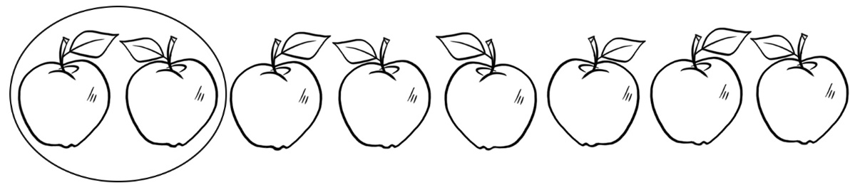
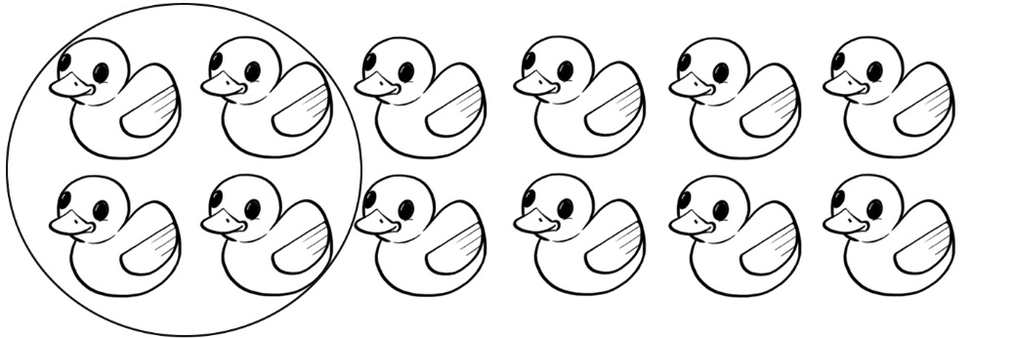

Equal-Sharing Problems
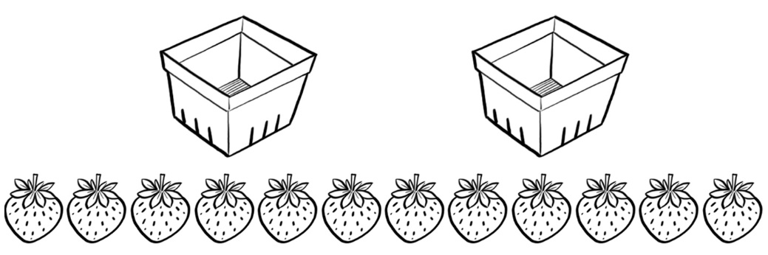
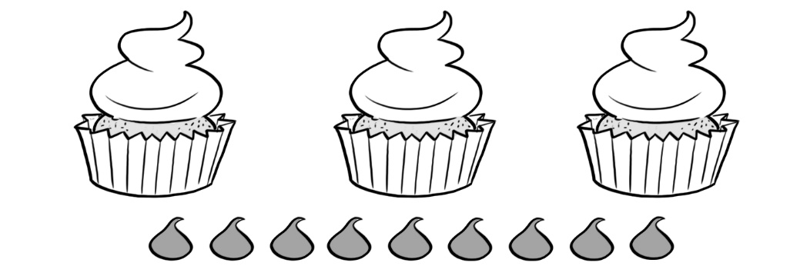
Division Problems
(Combined Grades Extension)
Master 113c

Equal-Grouping Problems
Nathan has 45 building blocks. He wants to build towers with  9 cubes in each. How many towers can Nathan build? | Luca has 72 pieces of pepperoni. He wants to put  9 pieces on each small pizza. How many pizzas can  Luca make?
Mia raised $56 selling face masks for her school.  Each mask sold for $7.  How many masks did she sell? | There are 48 students waiting to go on the roller coaster. Each car holds 6 students. How many cars will they fill?

Equal-Sharing Problems
Camilla wants to share  50 apples equally among the 10 horses in the stable.  How many apples should each horse get? | Five students are to take equal turns playing a video game. They have 45 minutes altogether. How long is each student’s turn?
There are 54 chairs. They are to be divided equally among  9 tables. How many chairs will be at each table? | Jonah has collected 32 toys from kids’ meals. He wants to display them equally on  4 shelves. How many toys will be on each shelf?

