Modelling Dollars and Cents to 200 Behaviours/Strategies
- Student models amount in one way (using smaller denominations).  “I used nickels to make 95¢ because I know how to skip-count by 5s: 5, 10, 5, …, 85, 90, 95.” | - Student models amount in more than one way, but trade was not accurate.  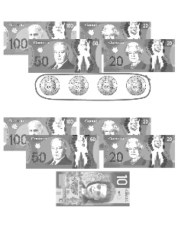  “I traded 4 toonies for a $10 bill.” | - Student models amount in more than one way and skip-counts to check.  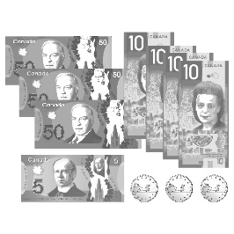  “50, 100, 150, 160, 170, 180, 190, 195, 196, 197, 198. The collection has a value of $198.” | - Student successfully models amount in different ways and finds fewest number of coins and/or bills needed.  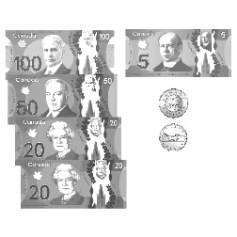  “To find the fewest number, I traded smaller coins/bills for larger coins/bills until I could make no more trades.”
Observations/Documentation

