**Repeating Patterns Around Us**

**Master 13**

**Wall Art**

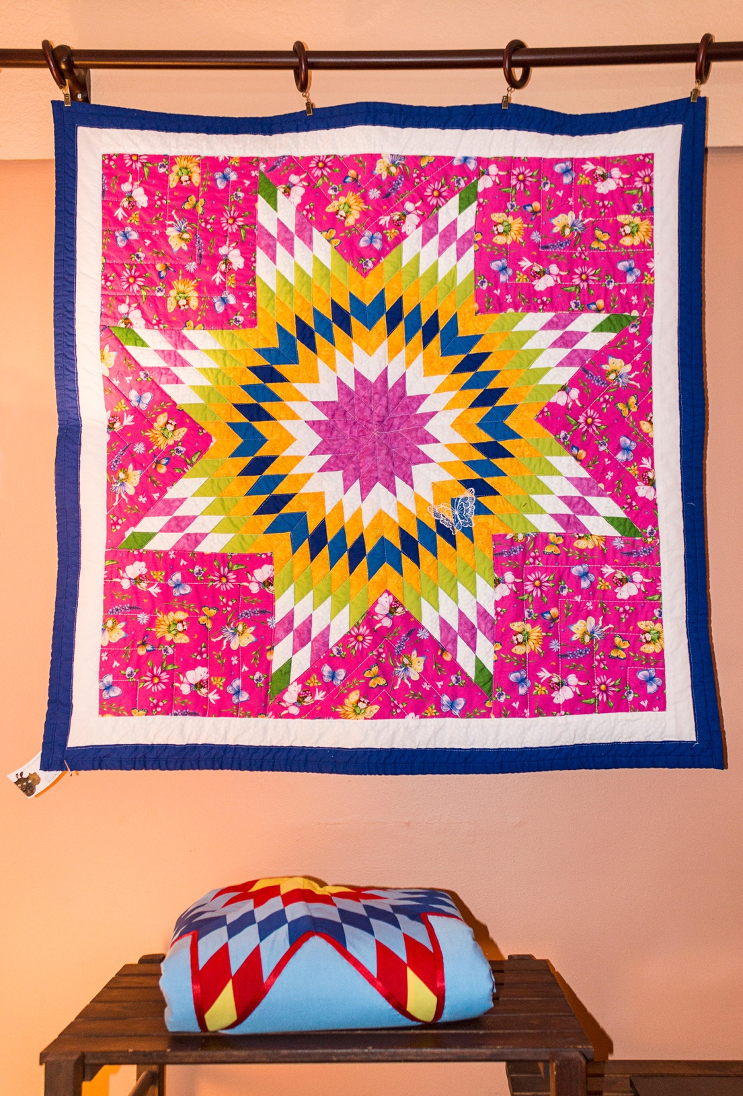

**Crosswalk**

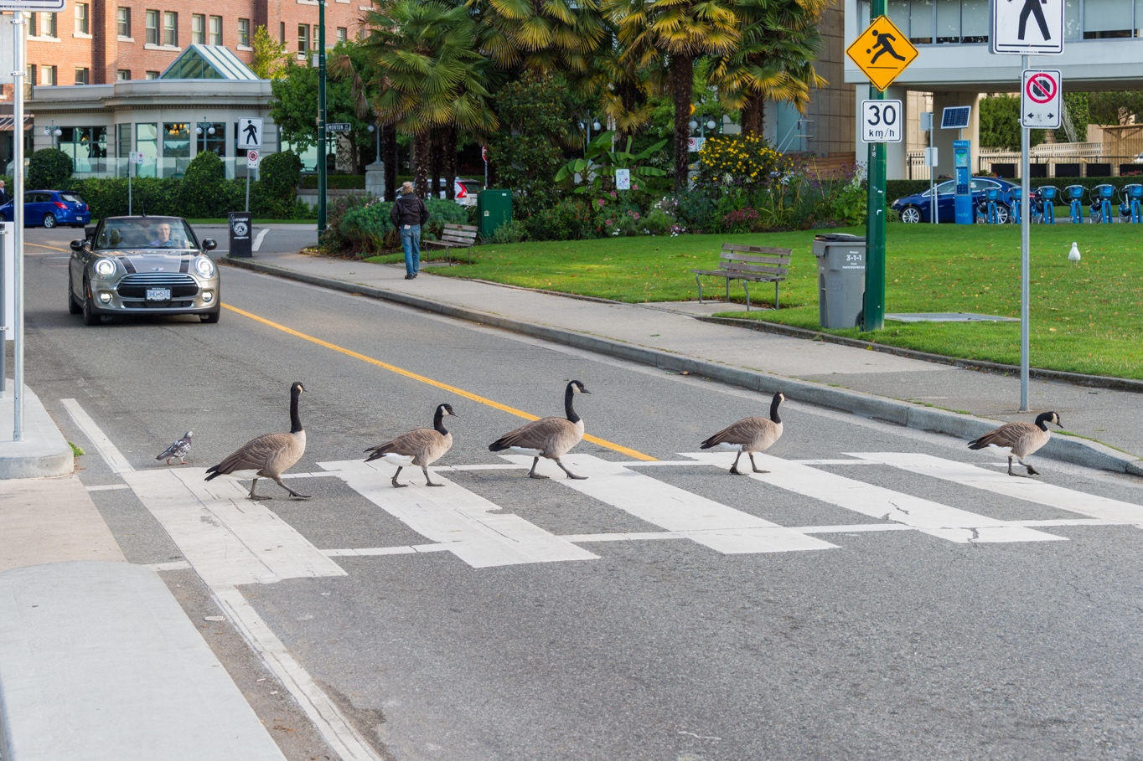

**Paving Stones**

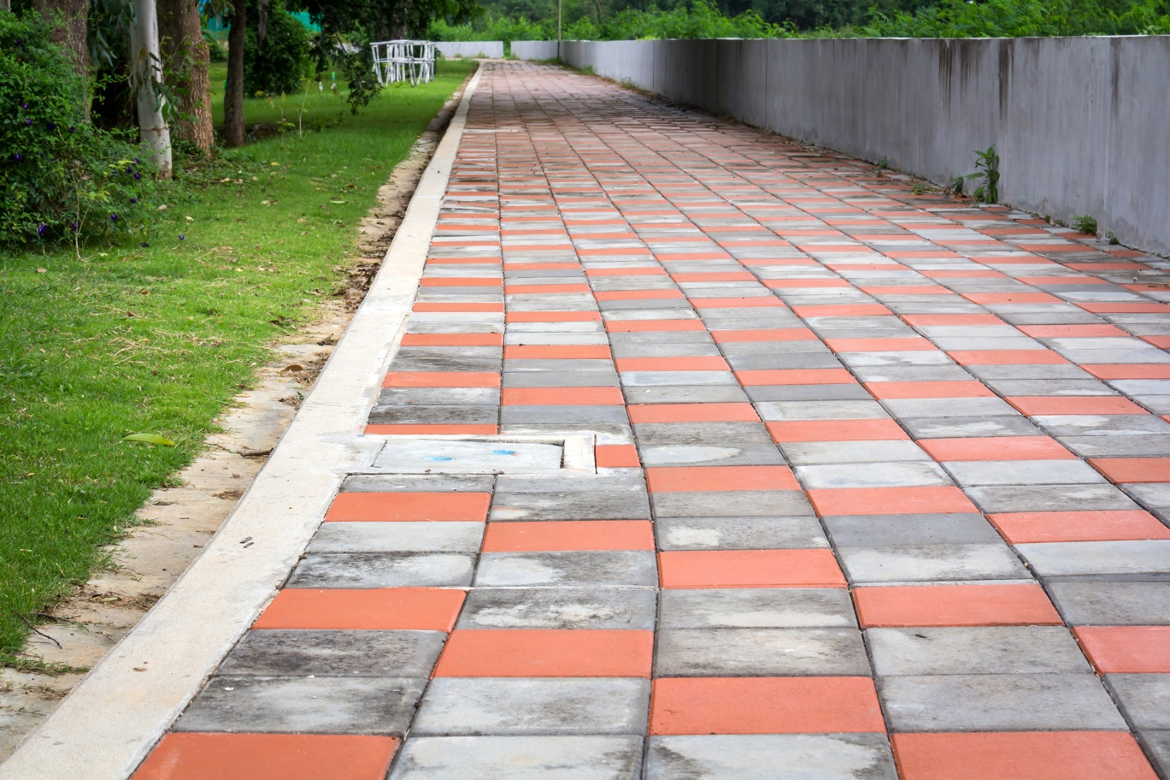

**Garden Path**

