**Number String Cards**

**Master 31a**

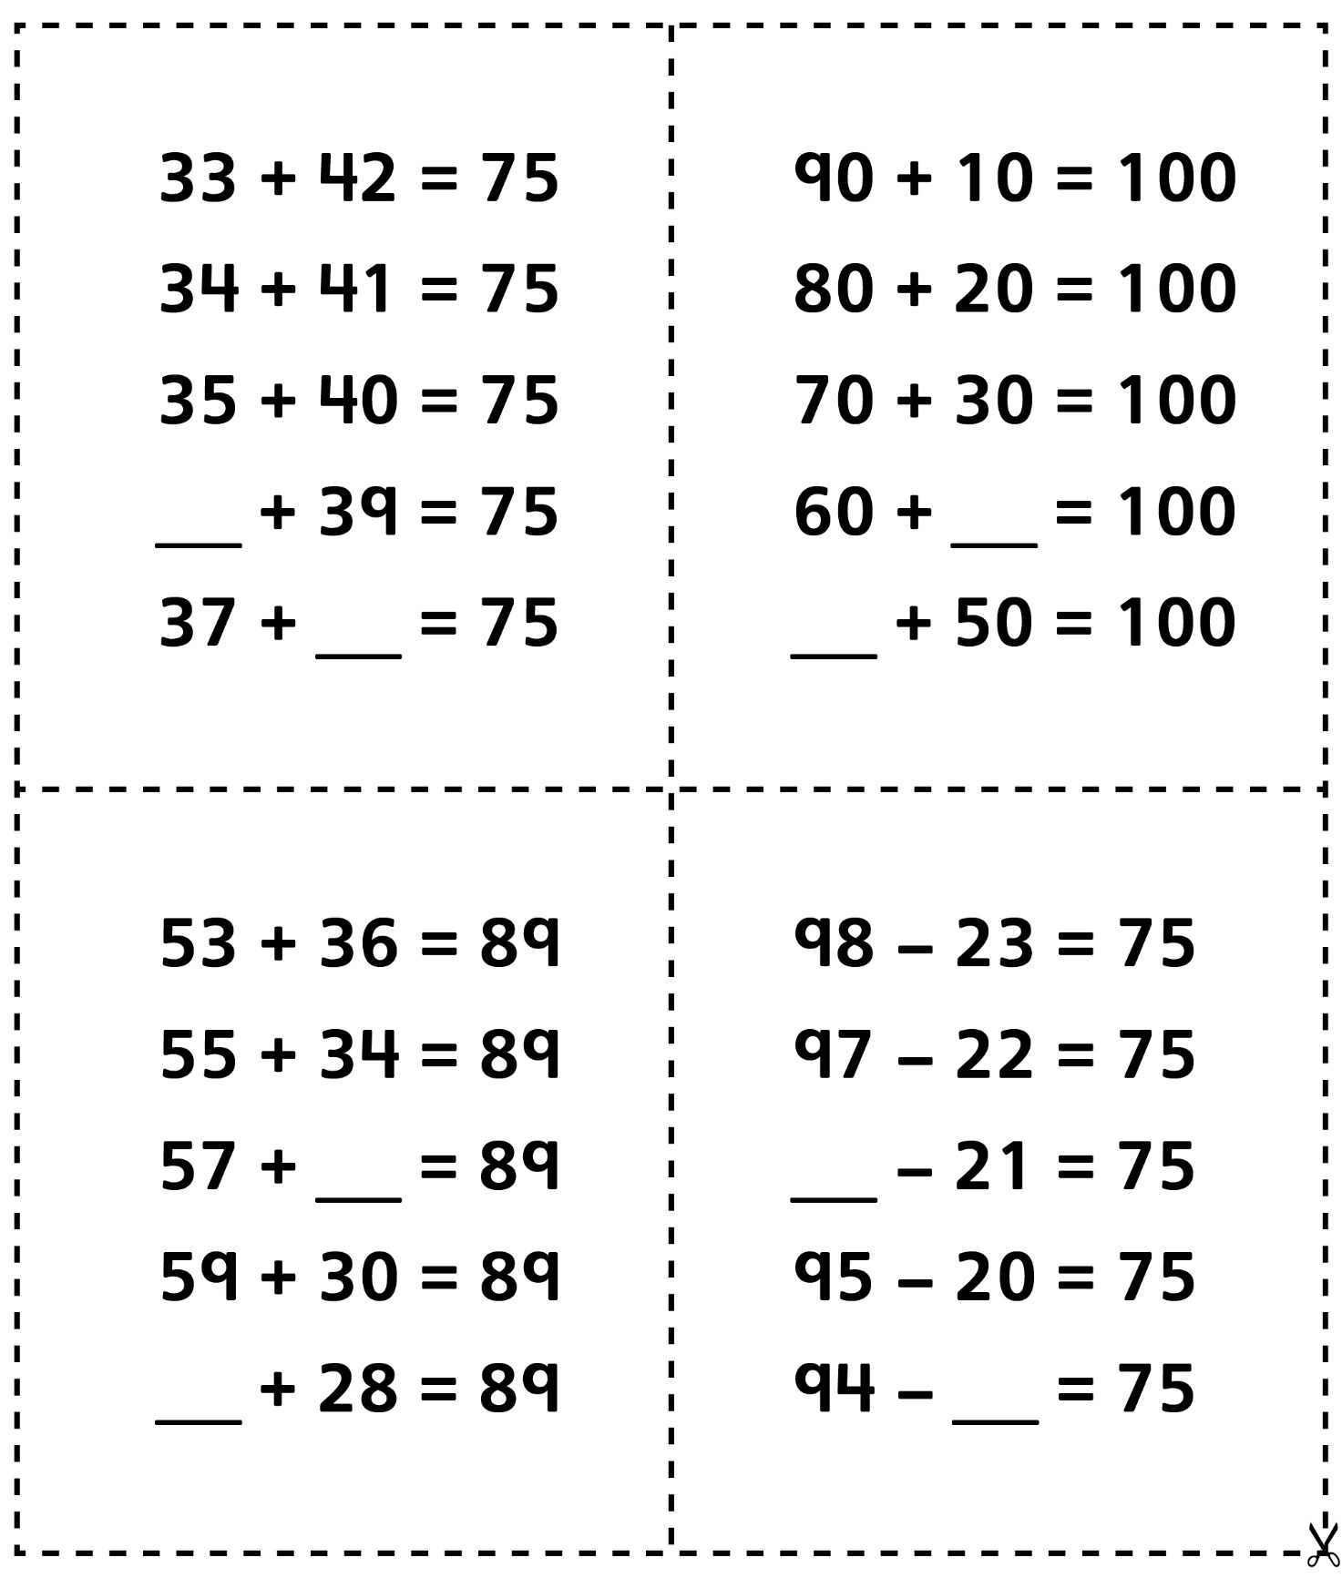

**Number String Cards**

**Master 31b**

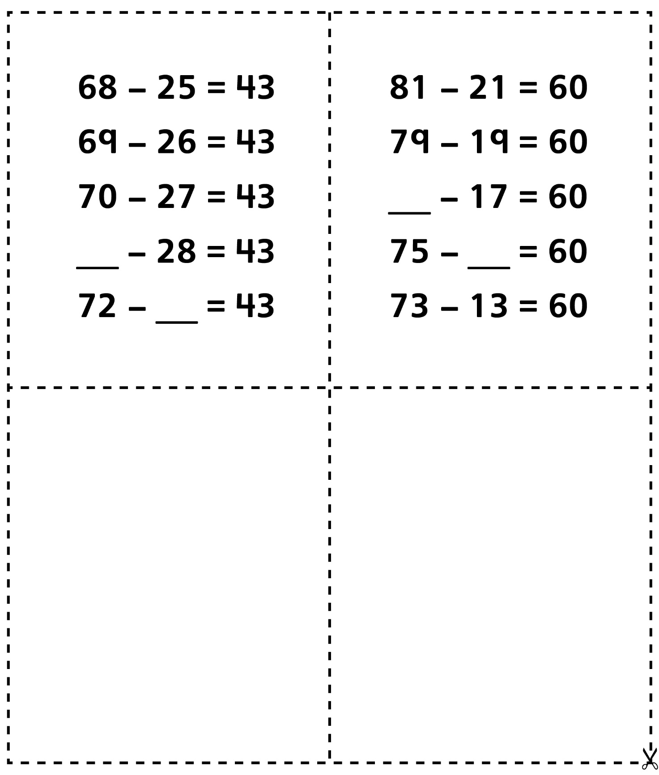

**Number String Cards** (Accommodations)

**Master 31c**

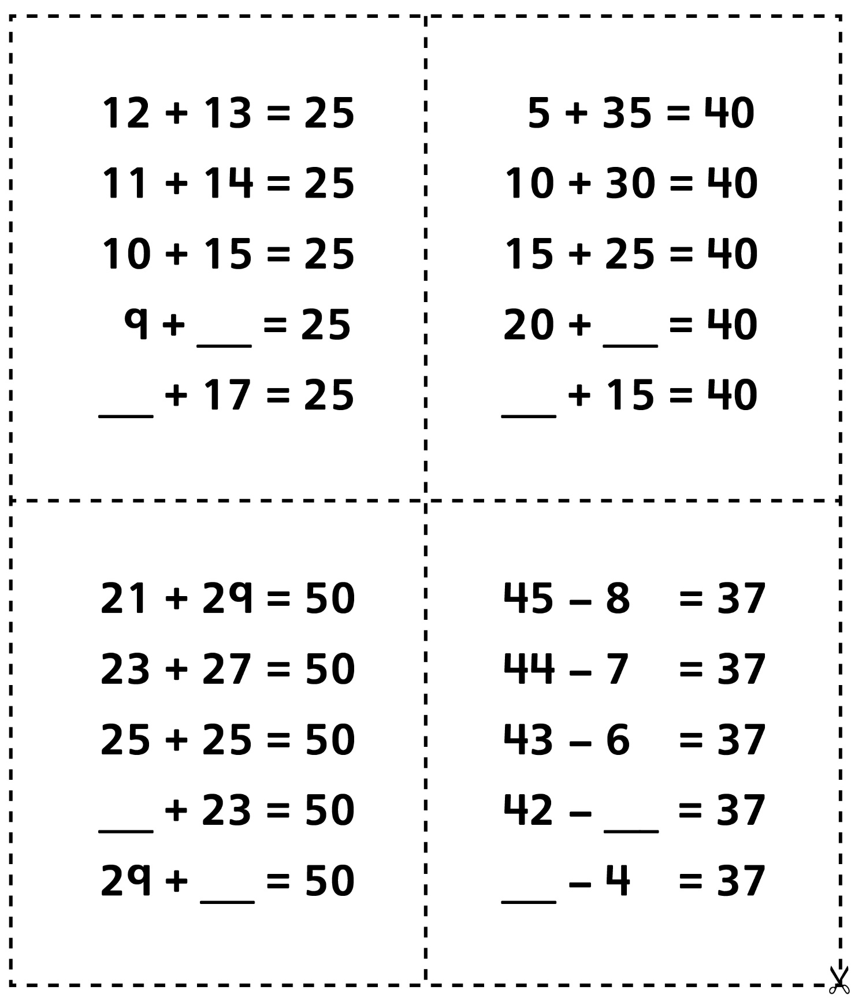

**Number String Cards** (Accommodations)

**Master 31d**

