Identifying and Reproducing Decreasing Patterns Behaviours/Strategies
- Student identifies decreasing patterns, but  struggles to reproduce them concretely  (is unable to build the patterns with tiles). | - Student identifies and reproduces decreasing  patterns concretely, but miscounts when  counting the number of tiles in each term.  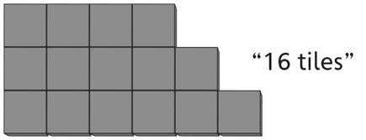 | - Student identifies and reproduces decreasing  patterns concretely and numerically, but  struggles to describe the patterns (cannot write  pattern rules).  “Take away 3 tiles”
Observations/Documentation
- Student identifies and reproduces decreasing  patterns concretely and numerically and  describes the patterns, but struggles to predict  the number of tiles in the next term.  “How do I know how many tiles are  in the next term?” | - Student identifies decreasing patterns numerically and describes the patterns, but does not see the relation to skip-counting backward or repeated subtraction.  “10, 8, 6  I don’t see how this is like subtracting or  skip-counting.” | - Student successfully identifies and reproduces  decreasing patterns concretely, pictorially, and  numerically and describes the patterns.  “10, 8, 6  Start at 10. Take away 2 each time.  This is like skip-counting backward by 2s from 10.”
Observations/Documentation

