Identifying Equal and Not Equal Number Sentences Behaviours/Strategies
- Student turns over a card, but struggles to model equality and inequality with cubes (miscounts) or only models one number on each side. | - Student models each side of number sentence with cubes and compares expressions (cubes) using one-to-one matching.  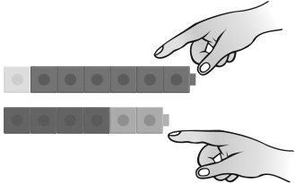 | - Student models each side of number sentence  with cubes and compares expressions (cubes)  using counting.  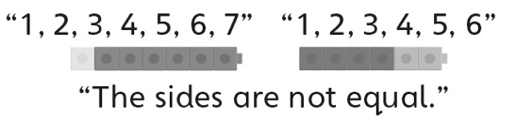
Observations/Documentation
- Student models equality and inequality with  cubes, but struggles to interpret the pan balance. | - Student models equality and inequality with  cubes and compares expressions, but does not understand when to use the equal (=) and not equal (≠) symbols.  “I’m not sure which sign to use.” | - Student models and describes equality and  inequality, and understands and uses the equal  (=) and not equal (≠) symbols when comparing  expressions.
Observations/Documentation

