***Equal Match* Cards**

**Master 45a**

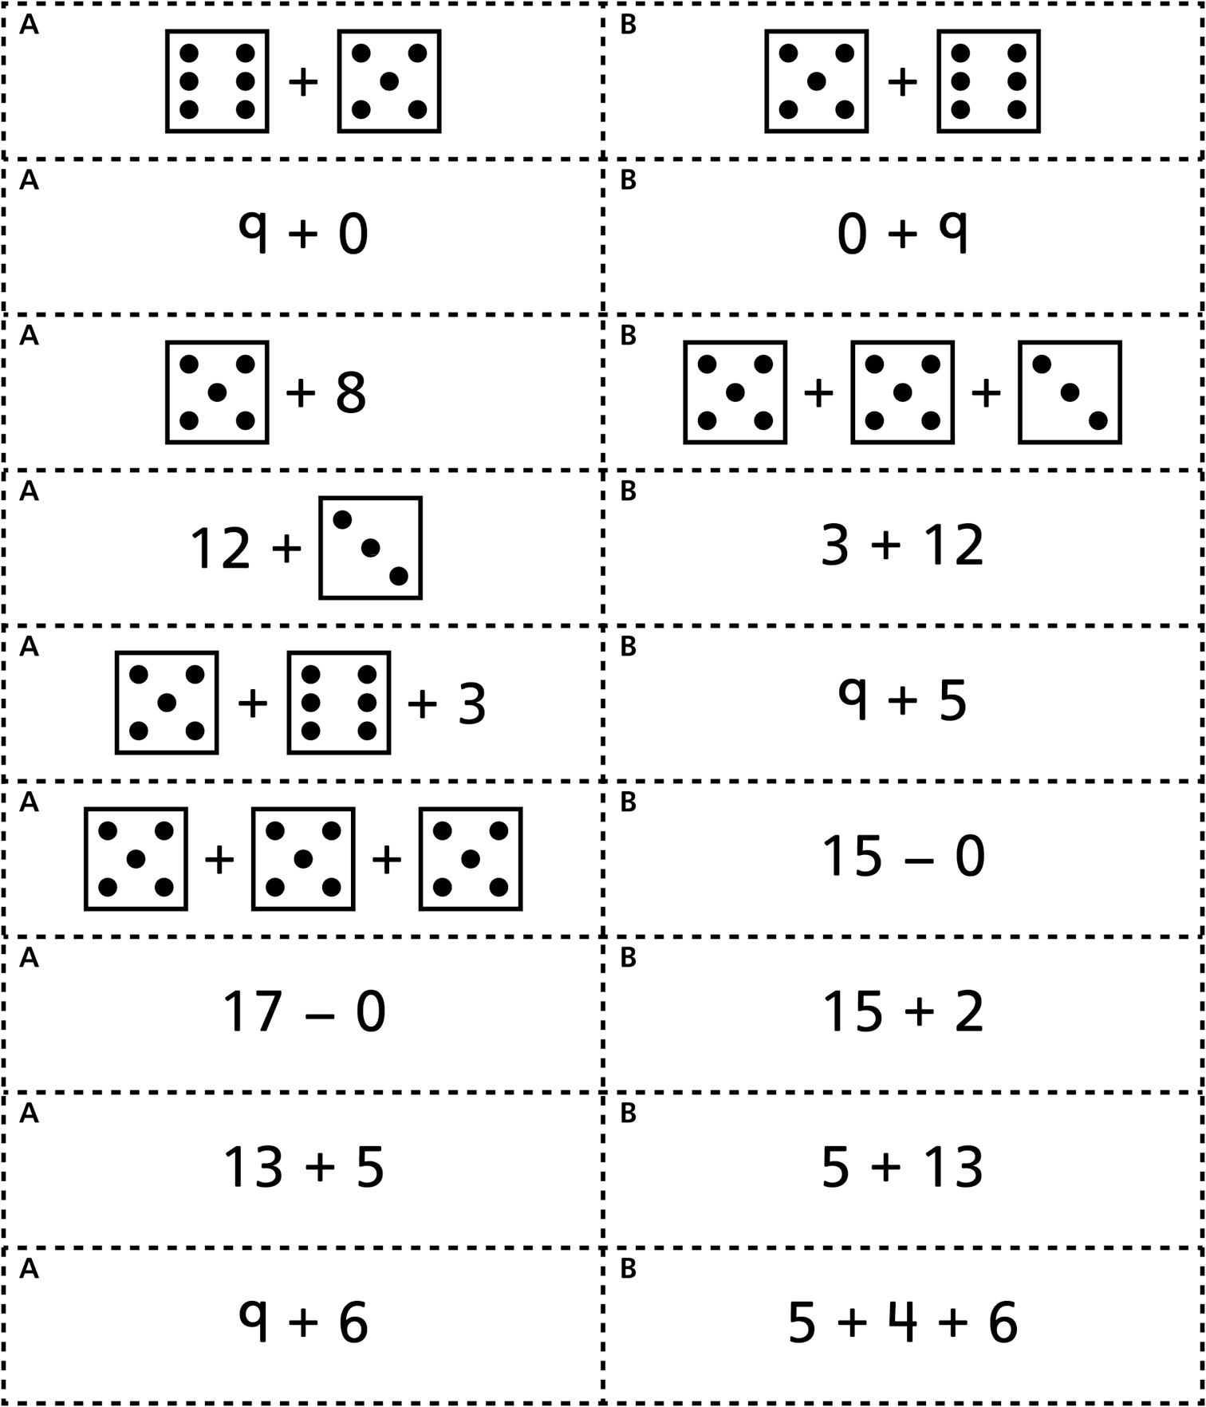

***Related Operations* Match Cards**

**Master 45b**

***Equal Match* Cards   
(for *Accommodations*)**

**Master 45c**

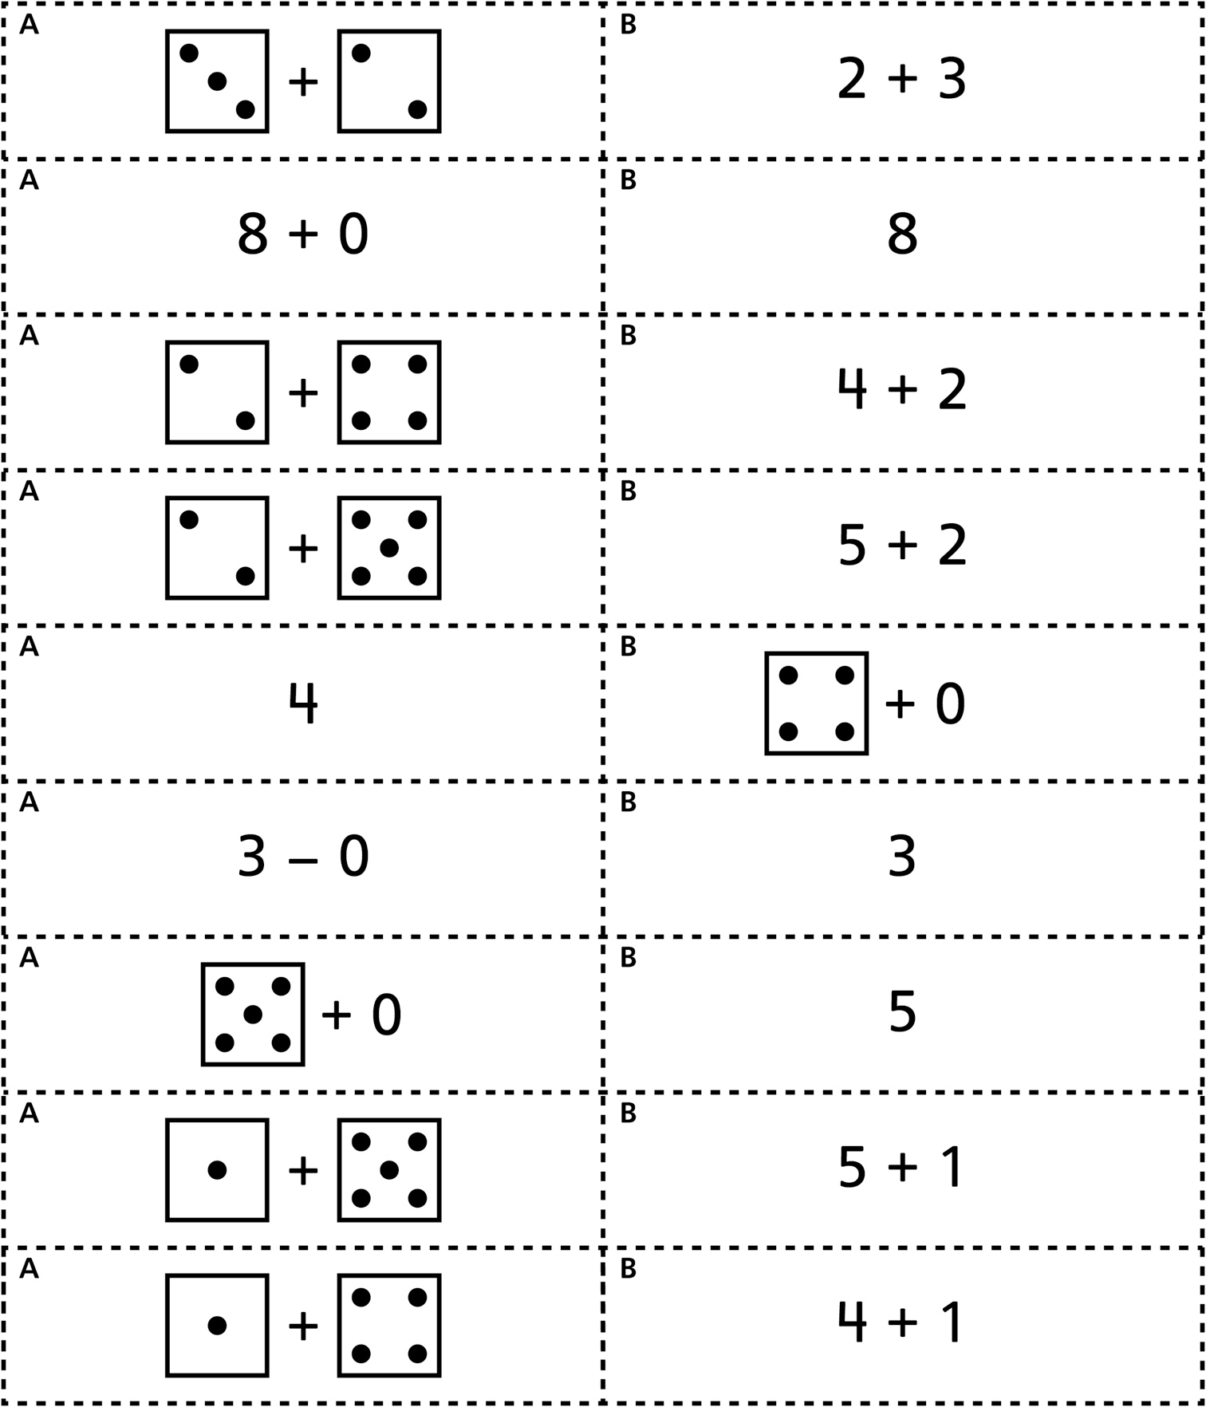

***Equal Match* Cards**

**Master 45d**

