***Find the Missing Number* Cards**

**Master 47a**

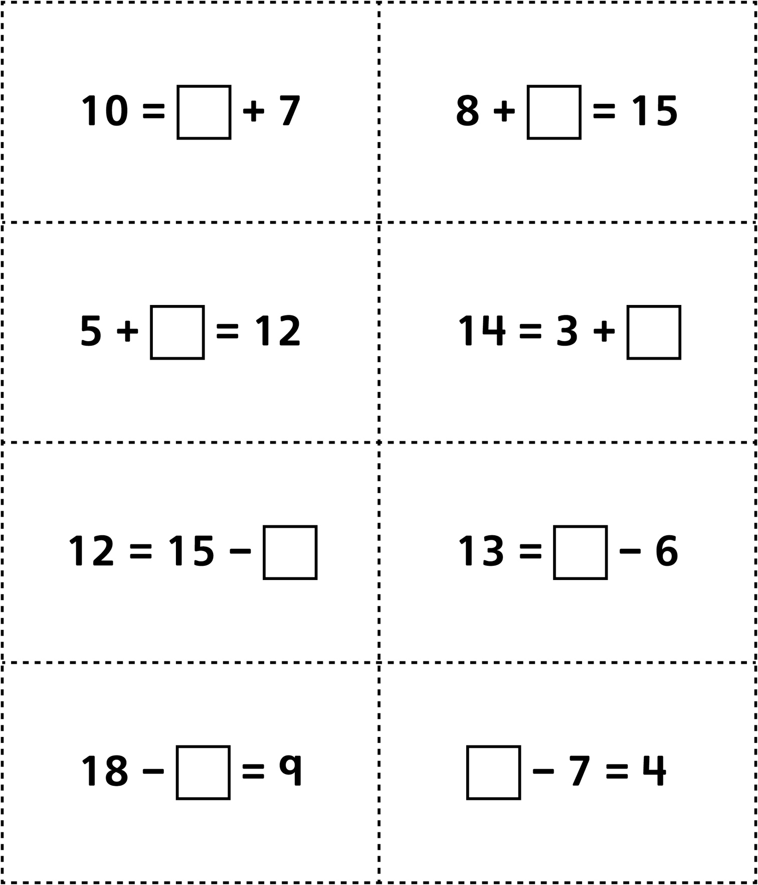

***Find the Missing Number* Cards**

**Master 47b**

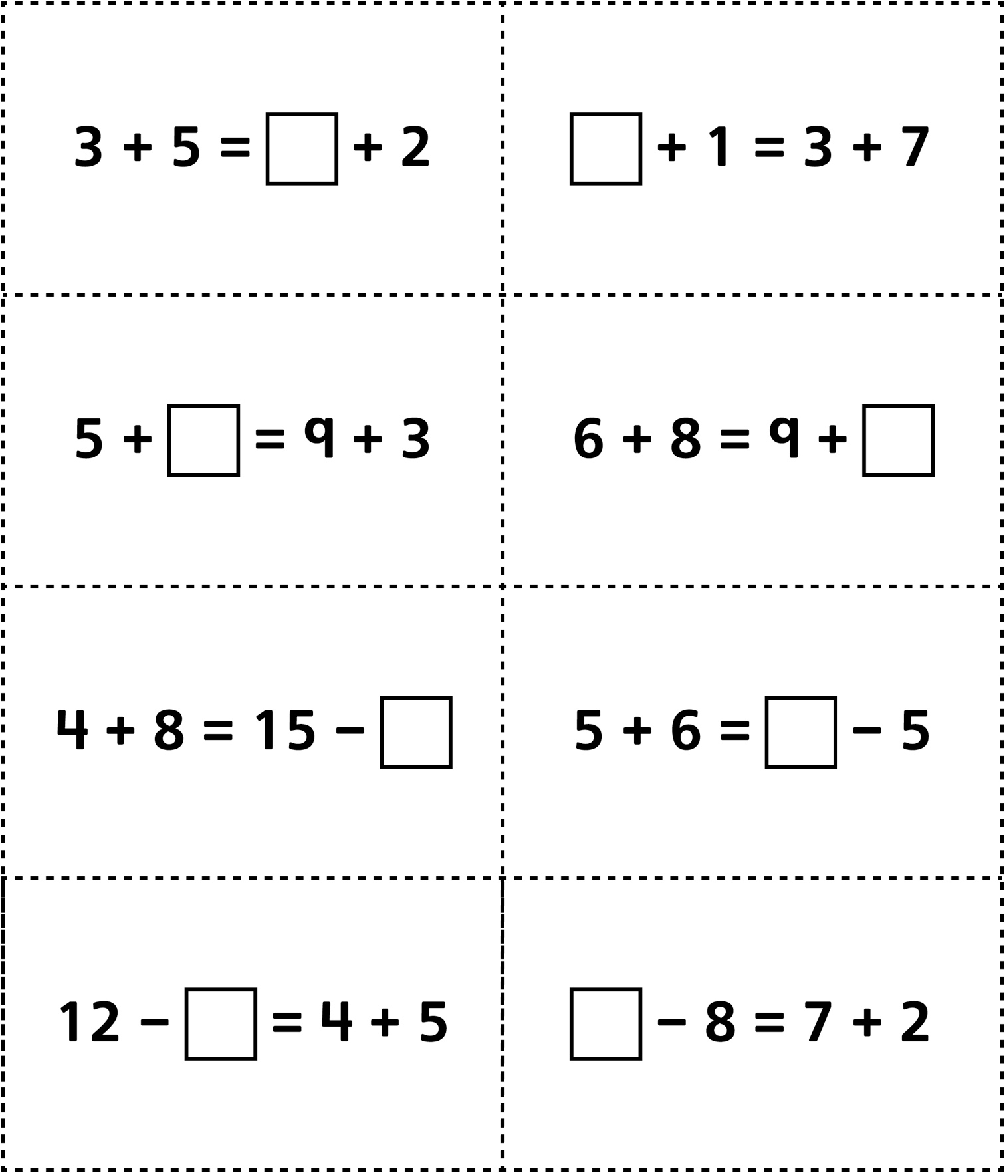

***Find the Missing Number* Cards**

**Master 47c**

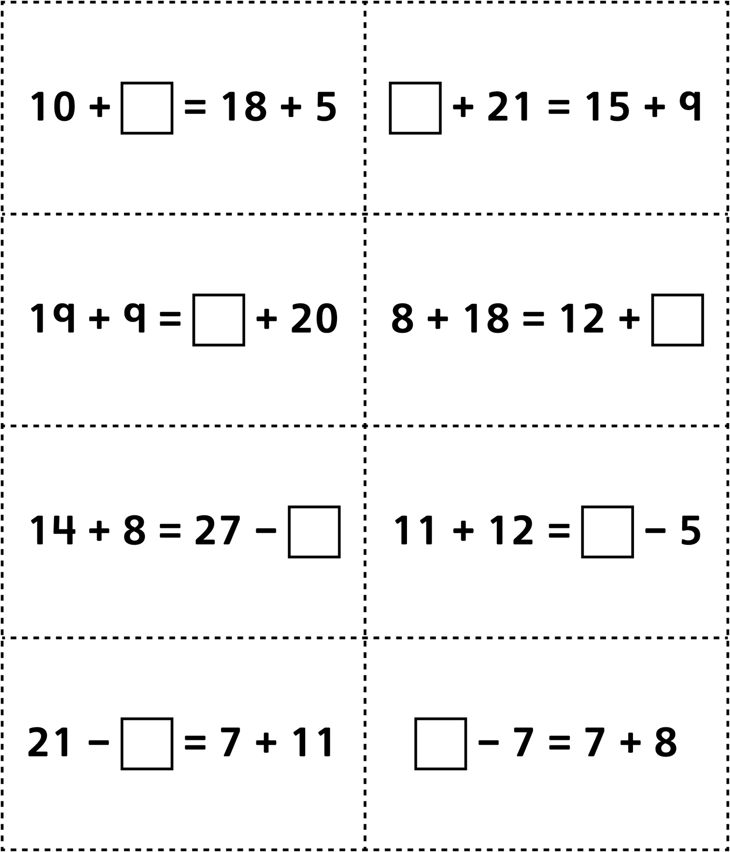

***Find the Missing Number* Cards  
(for *Accommodations*)**

**Master 47d**

