Our Venn Diagram
Master 3

__________________ __________________

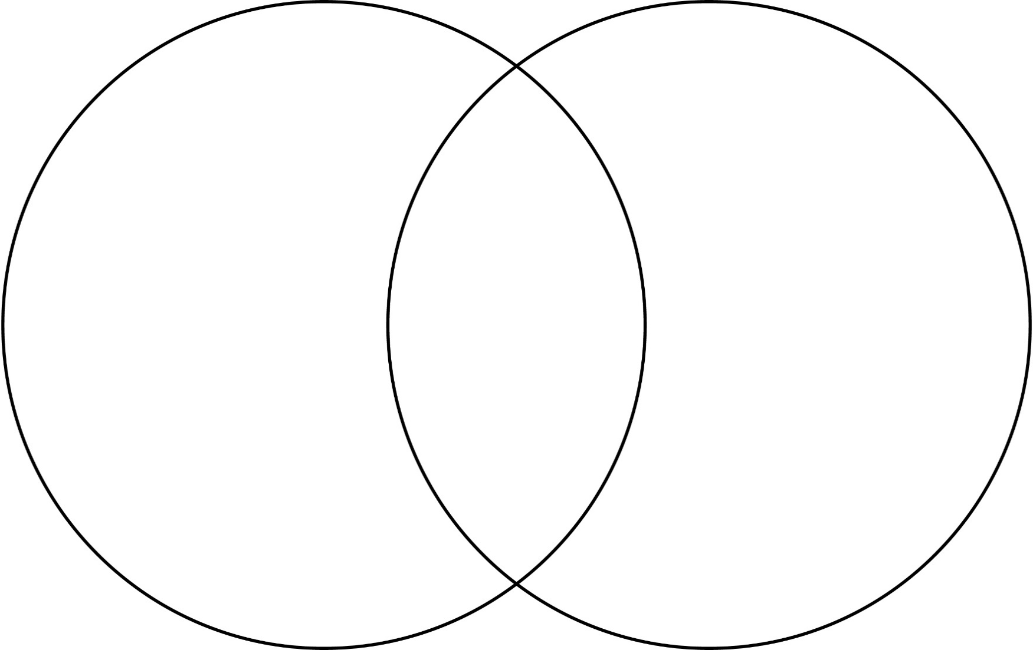

Our Venn Diagram (3 Loops)
(Combined Grades Extension)
Master 3b

__________________ __________________





