Using the Language of Chance Behaviours/Strategies
- Student struggles to describe the likelihood of an event and chooses words randomly. | - Student describes the likelihood of an event, but decision is based on beliefs or what she or he wants to happen. | - Student describes the likelihood of an event, but cannot justify thinking.  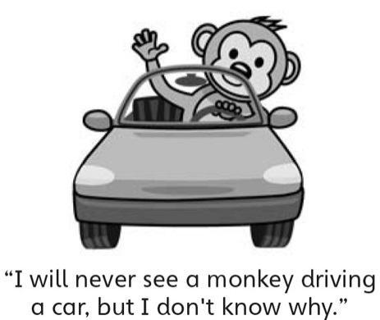 | - Student successfully describes the likelihood of an event and justifies thinking.  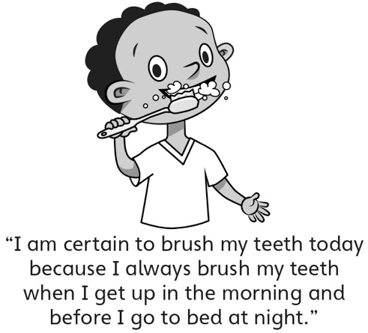
Observations/Documentation

