Covering Outlines in Different Ways Behaviours/Strategies
- Student covers a picture outline with shapes, but places blocks randomly or with gaps/overlaps.  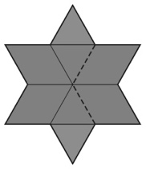 | - Student covers a picture outline with shapes,  but always tries to place matching blocks in the same relative position.  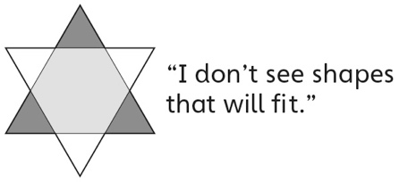 | - Student covers a picture outline with shapes, but uses all green triangles.
Observations/Documentation
- Student successfully completes a picture outline with shapes in one way, but removes all blocks to show another way.  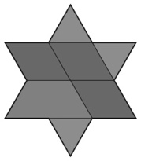 | - Student successfully completes a picture outline with shapes in one way and trades blocks to show another way, but struggles to describe/name the shapes used. | - Student successfully completes a picture outline with shapes in more than one way and uses math language to describe/name shapes used.  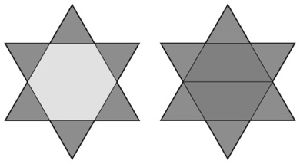
Observations/Documentation

