Comparing Quantities to 10 Behaviours/Strategies
- Student turns over a domino,  but struggles to say the number sequence starting with 1 and counting forward.  “1, 2, 4, 6, 5, 7” | - Student says the number sequence forward, but struggles to coordinate number words with counting actions (e.g., loses track of the count, misses dots in the count, or counts dots more than once).  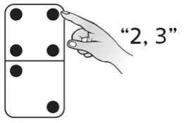 | - Student perceptually compares the quantities.  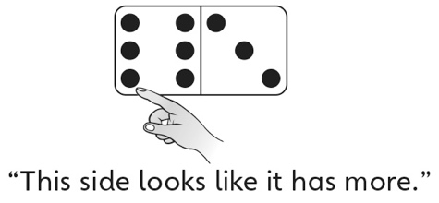 | - Student compares quantities using one-to-one matching.  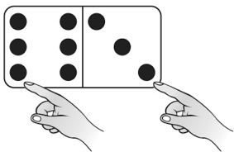
Observations/Documentation
- Student compares quantities using counting.  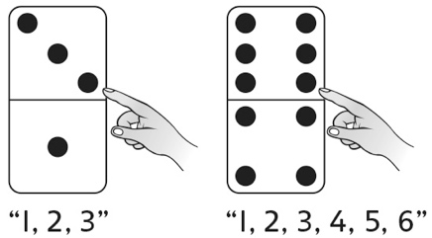 | - Student uses grouping to compare quantities without counting by 1s (conceptual subitizing).  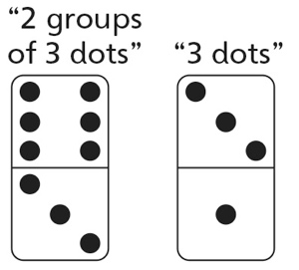 | - Student compares quantities using benchmarks.  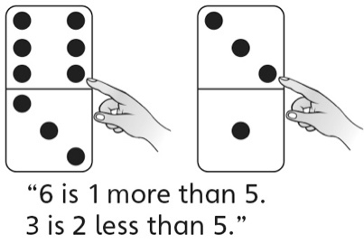 | - Student uses mental strategies  to successfully and efficiently  compare quantities to 10.  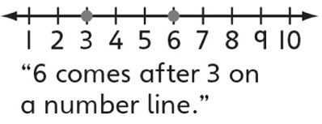
Observations/Documentation

