**Fill Me In!**

**Math Every Day: Master 10a**

**Pattern Block Outlines**

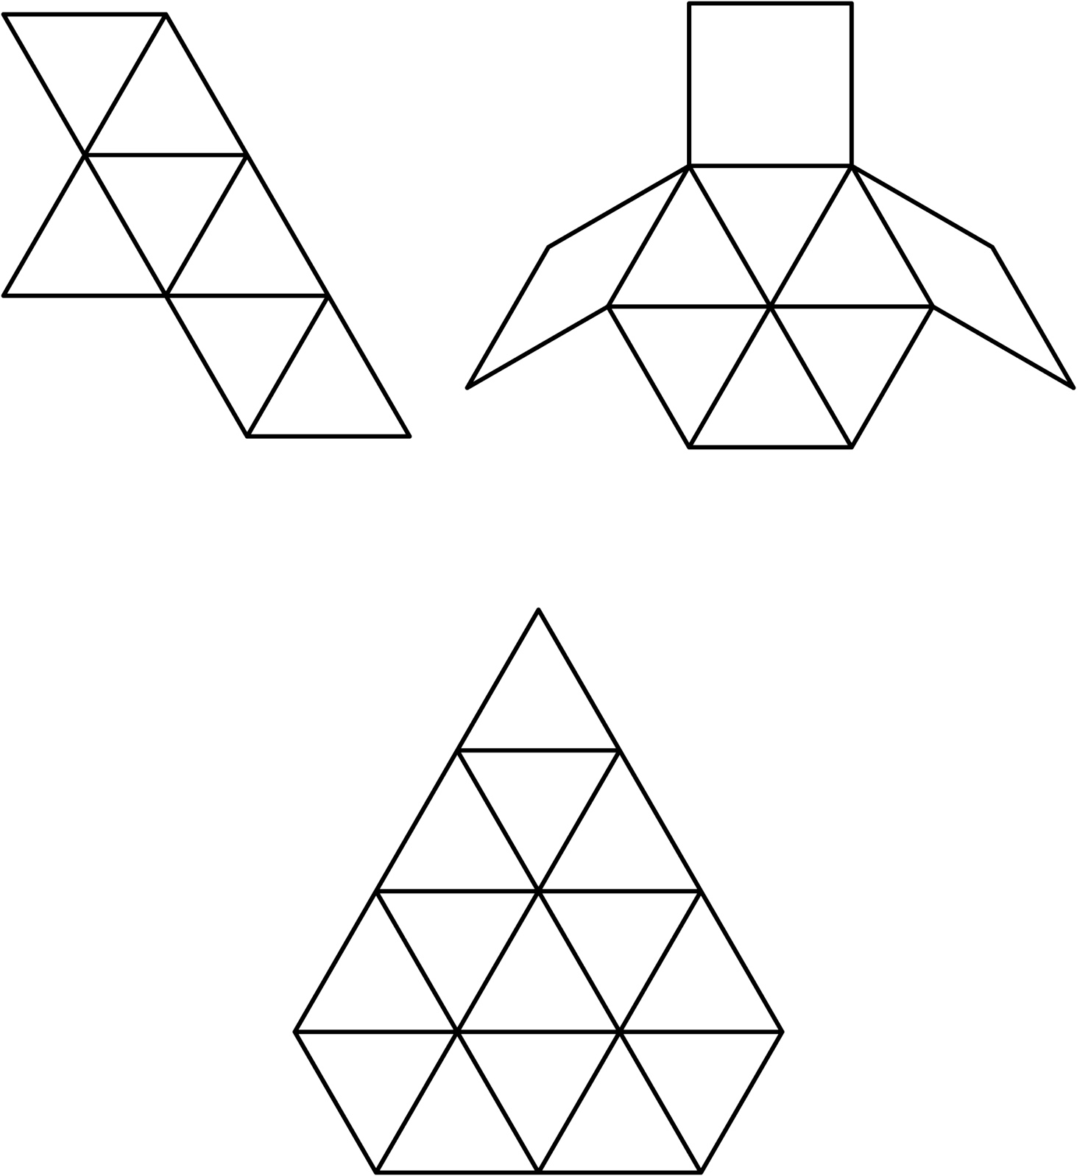

**Fill Me In!**

**Math Every Day: Master 10b**

**Pattern Block Outlines**

