Exploring the Likelihood of Events Behaviours/Strategies
- Student reads card, but struggles to understand chance word used to describe likelihood of event. | - Student knows chance word used to describe  likelihood of event, but does not know where to start to make matching bag.  “How do I to make a bag where  a red counter is more likely?” | - Student knows chance word and makes  matching bag, but thinks only one bag is  possible.  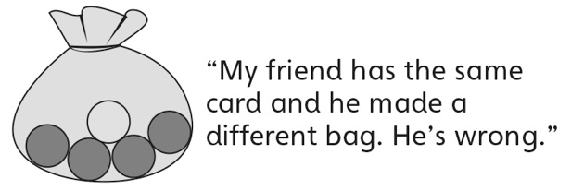
Observations/Documentation
- Student describes the likelihood of events and  makes matching bag, but struggles to justify  thinking.  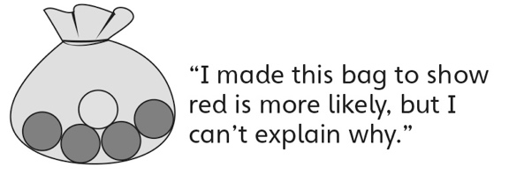 | - Student successfully describes the likelihood of events and makes matching bag, but does not understand why results of experiment do not match prediction.  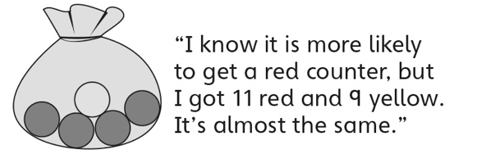 | - Student successfully describes the likelihood  of events, makes matching bag, and performs  simple experiments to verify predictions.
Observations/Documentation

Big Idea |  |  |  |  | Indicators from Learning Progression
Curriculum Expectations addressed

Student Names
Student can create an event/pair of events to match each chance word.
(Activities 7)
Student can compare events to decide which event is more/less likely or whether they are equally likely.
(Activities 7, 8, 9)
Student can use the language of chance to
describe the likelihood of events.
(Activities 7, 8, 9)
Student can place events along a value line in the appropriate positions.
(Activities 7)
Student can use a chance word to describe a bag of counters or a spinner.
(Activities 8)
Student can conduct a simple probability experiment to check his or her prediction.
(Activities 8, 9)
Student can make a bag of counters to match an event.
(Activities 9)

Name: _______________________

 | Not Observed | Sometimes | Consistently
Creates an event/pair of events to match each chance word.
(Activities 7)
Compares events to decide which event is more/less likely or whether they are equally likely.
(Activities 7, 8, 9)
Uses the language of chance to describe the likelihood of events.
(Activities 7, 8, 9)
Places events along a value line in the appropriate positions.
(Activities 7)
Uses a chance word to describe a bag of counters or a spinner.
(Activities 8)
Conducts a simple probability experiment to check his or her prediction.
(Activities 8, 9)
Makes a bag of counters to match an event.
(Activities 9)

Strengths:

Next Steps:

