Attribute Cards for Activity 2
Master 2a

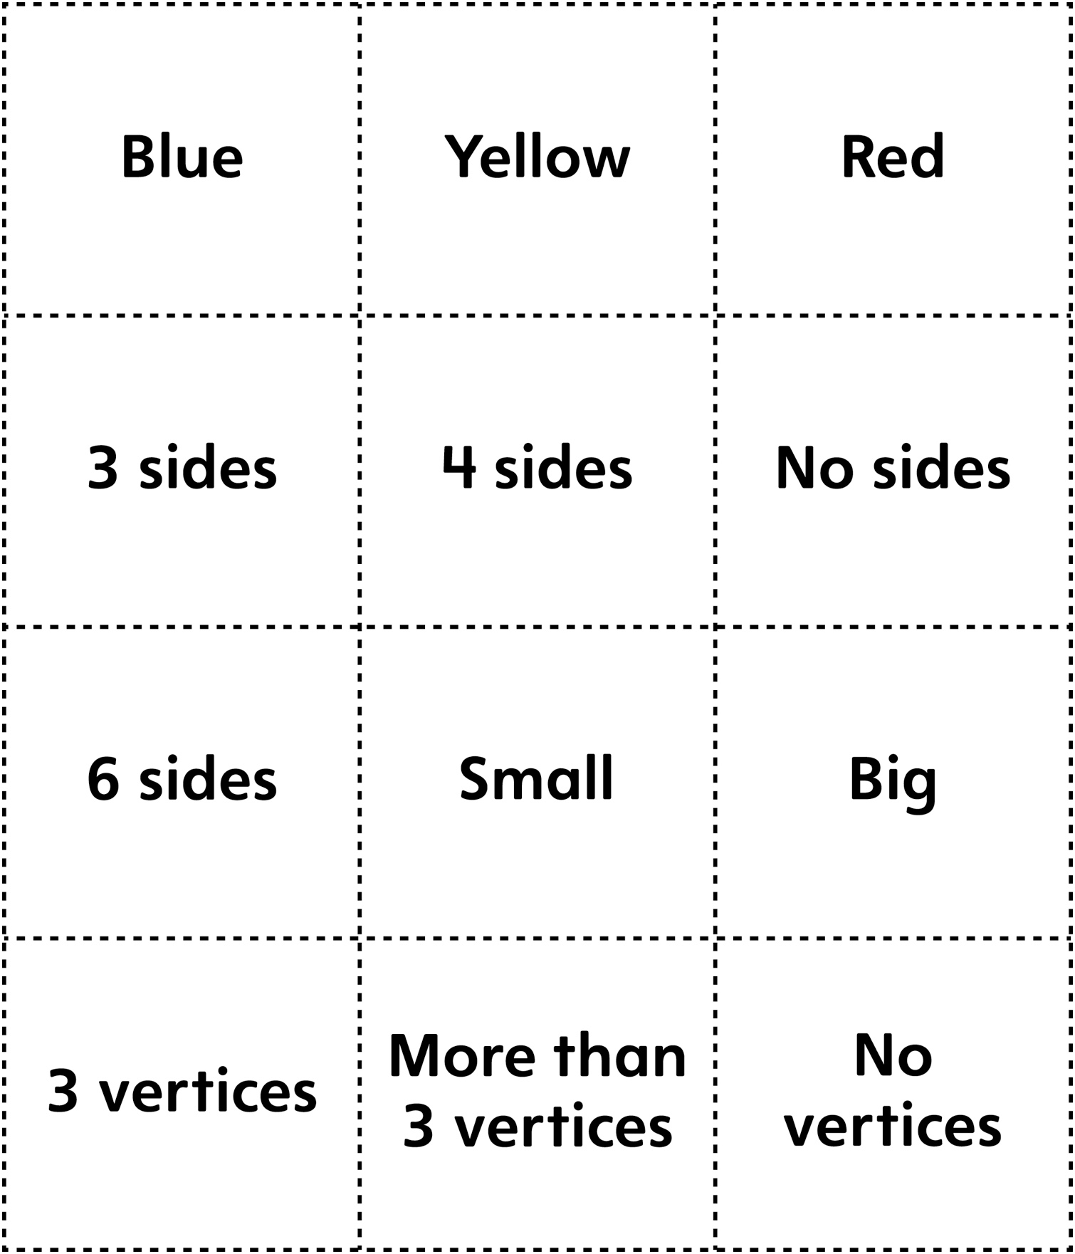

Attribute Cards for Activity 2
Master 2b

(for Combined Grades Extension)

